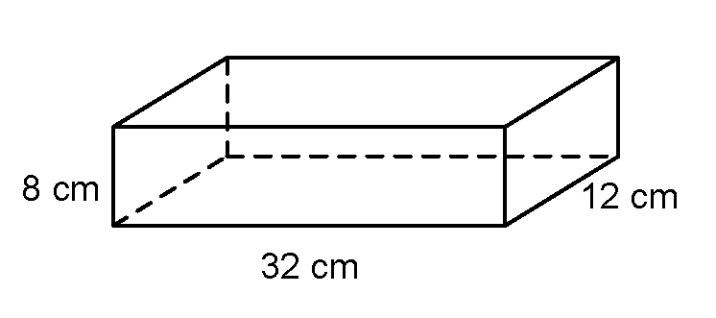
Section 7.4 Extra Practice
1. You need to fit 4-cm cubes into this box.
a) How many cubes will fit along the length? ____
b) How many cubes will fit in the base? ____
c) How high could the cubes be stacked? ____
d) How many cubes could you fit in altogether? ____
e) Will they fit perfectly, leaving no extra space? YES NO Explain.
___________________________________________________________
___________________________________________________________
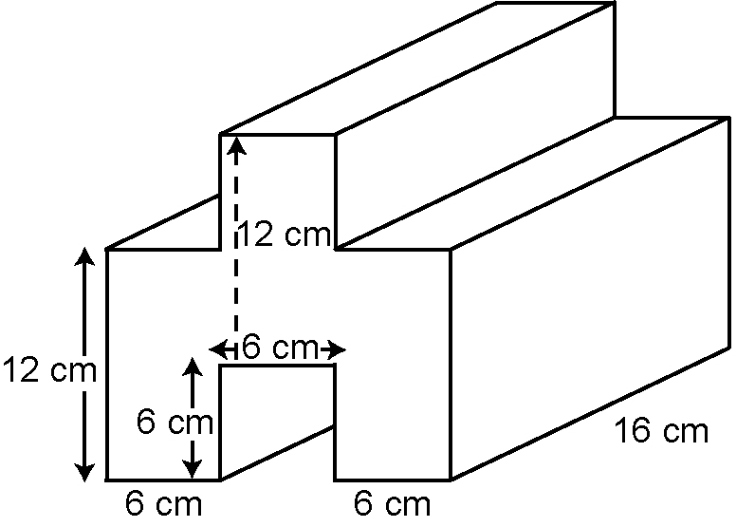
2. What is the volume of this shape?

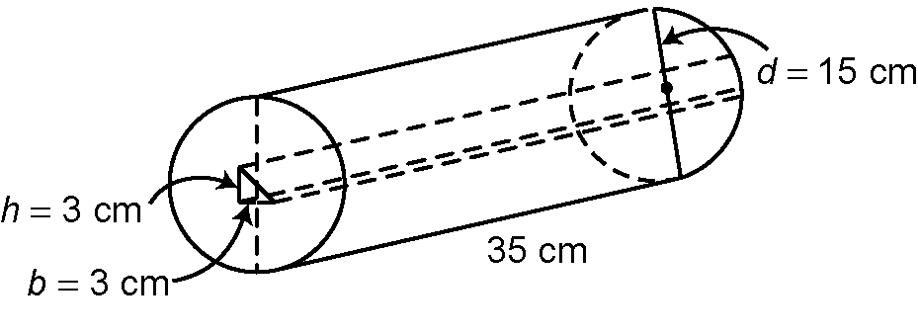
3. What is the volume of this shape with a
triangular hole through it? Show your
answer to two decimal places.

For #4a) and b), show your work in your notebook.
4. A box has a base of 20 cm by 20 cm. You want to fit cans with a diameter of 6.6 cm in the box. The height of the box is 10.2 cm and the height of each can is 10 cm.
a) Draw a diagram that shows how many cans fit in the box.
b) Calculate the volume of the box and the volume of one can. Divide the
volume of the box by the volume of the can.
c) Explain why the answers in parts a) and b) are not the same.
___________________________________________________________
___________________________________________________________

