Chapter 7 Test
For #1 to #5, choose the best answer.

1. Which units can be used to express volume?
A cm² B dm² C km³ D m

2. What is the volume of a right prism with a base area of 4.6 cm² and a height of 9.3 cm?
A 13.9 cm³ B 18.5 cm³ C 21.39 cm³ D 42.78 cm³
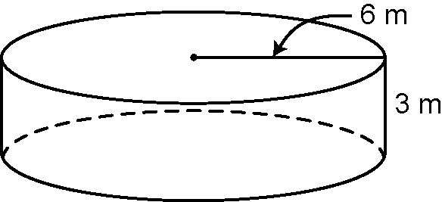
3. What is the volume of this right cylinder?
A 113.04 m³
B 169.56 m³
C 339.12 m³
D 678.24 m³

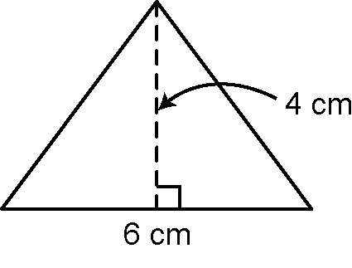
4. What is the height of a triangular
prism with a volume of 96 cm³ and
this triangular base?
A 4 cm
B 6 cm
C 8 cm
D 16 cm

5. What is the volume of a cube with an edge length of 2.3 m?
A 12.2 m³ B 24.3 m³ C 36.5 m³ D 48.7 m³

Short Answer

6. Calculate
a) the area of the base of a rectangular prism with a triangle height of 8 m and a triangle base of 2 m
b) the volume of a right cylinder with a radius of 6 mm and a height of
5 mm
c) the volume of a cube with an edge length of 6 cm
d) the volume of a right rectangular prism with dimensions 8.1 cm ×
5.3 cm × 10 cm
e) the area of the base of a right cylinder with a radius of 5 m
f) the height of a cube with a volume of 343 cm³ and a base area of 49 cm²
g) the area of the base of a right triangular prism with a volume of
392.7 km³ and a height of 8.5 km
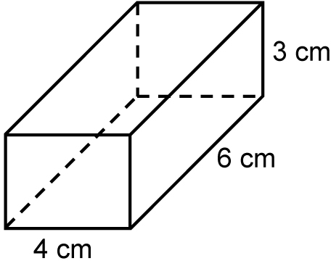
7. What is the volume of this right
rectangular prism?

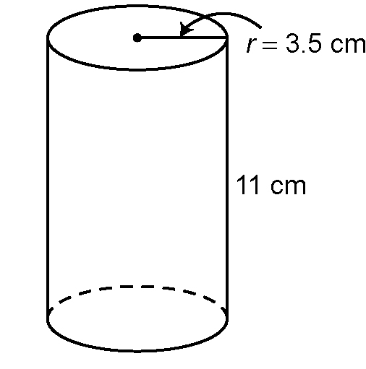
8. Lee placed three ice cubes with edge lengths
of 2 cm in this glass. What volume of juice will
he add to fill the glass to the top?

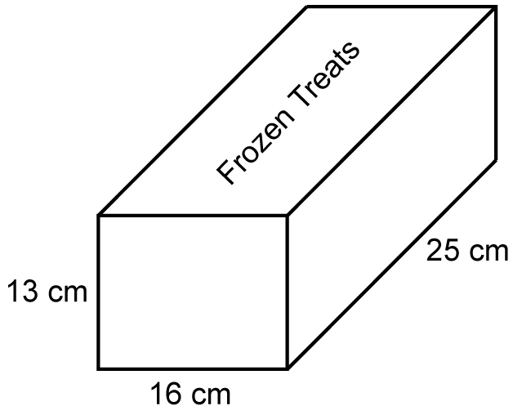
9. The inside of a freezer has a volume of 3.5 m³.
What is the volume of the space left in the
freezer after 120 boxes of these frozen treats
are placed in it?

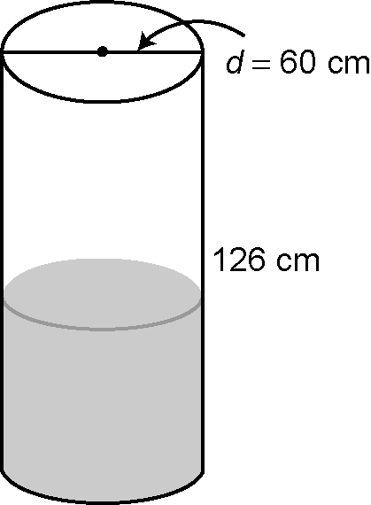
10. Jared fills this right cylinder barrel half-full of water.
a) What is the volume of the water in the barrel?
b) If 1 m³ = 1 000 000 cm³, how many m³ is the
volume of water in the barrel? Round your
answer to two decimal places.

Extended Response

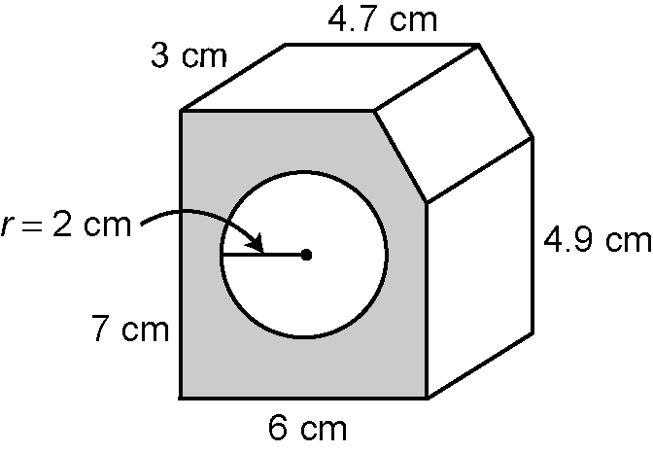
11. What is the volume of this right rectangular prism
shape? Round your answer to two decimal places.

