Chapter 7 BLM Answers

BLM 7–1 Chapter 7 Math Link Introduction
1. a)−c) Answers will vary depending on area.
2. a) Answers will vary. Communities spend money on parks to provide places for recreation.
b) Answers will vary. The money is spent on playground equipment, picnic tables, waste receptacles, sports nets, and maintenance.
3. Answers will vary. Example: 2-D shapes such as squares, rectangles, and circles; 3-D objects such as cubes, prisms, and cylinders.
4. a) Sketches will vary. Ensure that sketches are reasonable.
b) Answers will vary. Example: rectangular
c) Look for reasonable dimensions for the table top such as 1 m × 1 m or 1 m × 1.5 m.
d) Answers will vary depending on part c).
5. a) Sketches will vary. Ensure that sketches are reasonable.
b) Most garbage cans have a round base.
c) Look for a reasonable radius such as 0.3 m.
d) Answers will vary. Example: The area of a base with radius 0.3 m is 0.28 m².
BLM 7–2 Chapter 7 Get Ready
1. The right prisms are a) and c). The right cylinder is f). These figures have faces that meet the base at 90°.
2. Answers will vary. a) between 175 and 200 b) between 720 and 800
c) between 140 and 210
3. Have students round answers to tenths.
a) 416 cm² b) 123.8 m² c) 226.5 cm²
4. a) 4 × 4 × 4 b) 3 × 3 × 3 × 3 × 3
c) 7 × 7 d) 5 × 5 × 5 × 5
5. No, 3 to the power of 4 is 3 × 3 × 3 × 3, which is 81, and 4 to the power of 3 is 4 × 4 × 4, which is 64.
BLM 7–3 Chapter 7 Warm-Up
Section 7.1
1. 4 ÷ = 16. No, she does not have enough bran.
2. Answers will vary. Example: 1 scoop = 4 horses; 2 scoops = 8 horses; 4 scoops = 16 horses. No, she does not have enough bran.
3. 4. a cube
5. Answers will vary. Example:
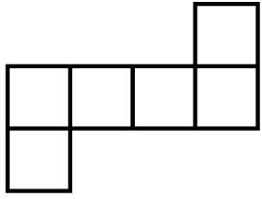
6. a) 4 b) 9 c) 49
d) Answers will vary. Example: Multiply the denominator of the fraction by the whole number.

7. a) 1 b) 1 c) 1
d) Answers will vary. Example: If you are multiplying a whole number by a fraction with
1 as a numerator, then the whole number becomes the numerator. If the denominator and the whole number have the same value, the answer will be 1.
8. 25 × 6 = 150 cm²
9. $500 × 1.5 = $500 + $250 = $750
10. $750 + $0.75 = $750.75
Section 7.2
1. 240 cm³
2. 240 cm³. Answers will vary. Example: The volume of a prism is the same, no matter which base you sit it on.
3. 20 cm³ 4. 550 cm³
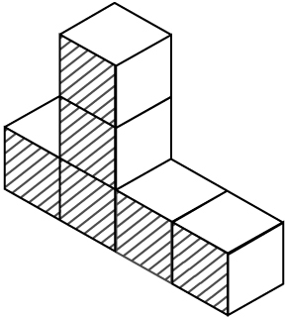
5.

6. a) $25 + $12.50 = $37.50 b) $7.50
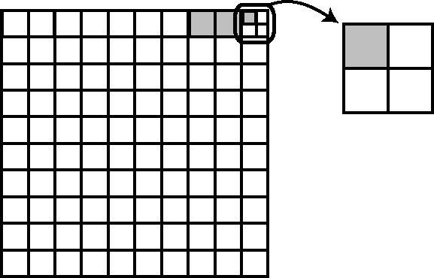
7.
8.

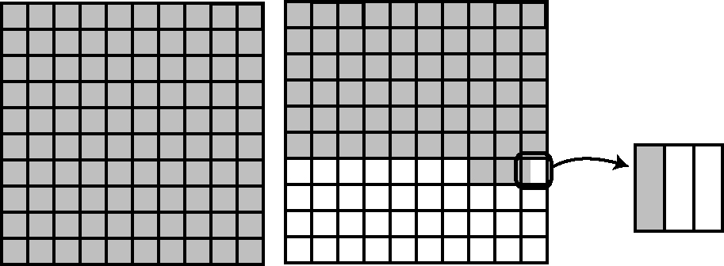
9.

10. 7² = 49; 8² = 64; ≈ 7.6
Section 7.3
1. 9.22 m³ 2. 3600 m³ 3. 49 cm³ 4. 36.8 cm³
5. Area of triangular sections: A = (3.5 × 7 ÷ 2) × 2; A = 24.5 cm². Area of two flat sections: A = 4 × 7.8 × 2; A = 62.4 cm². Area of end: A = 3.5 × 4; A = 14 cm². Total Area = 100.9 cm²
6. Area of triangular sections: A = (4 × 7 ÷ 2)
× 2; A = 28 cm². Area of two flat sections: A = 4 × 8 × 2; A = 64 cm². Area of end: A = 3 × 4; A = 12 cm². Total Area = 104 cm²
7. 4 8. 2 9. 150.1%, 1.501 10.
Section 7.4
1. Estimates may vary. Example: (30 × 30 × 3) × 10 = 27 000 cm³. Calculation: (25.8 × 25.8
× 3.14) × 10.2 = 21 319.117. The answer is
21 319 cm³.
2. Estimates may vary. Example: (3 × 3 × 3)
× 10 = 270 m³. Calculation: (3 × 3 × 3.14)
× 10 = 282.6. The answer is 283 m³.
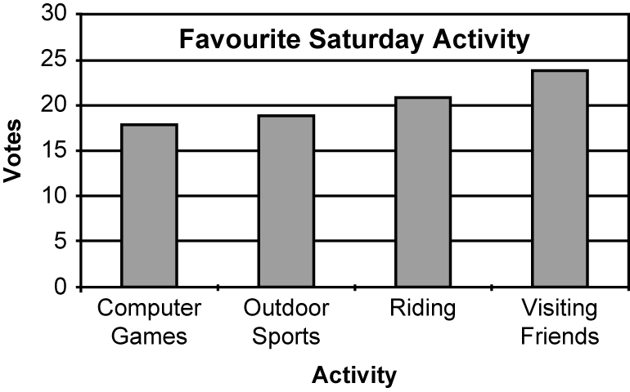
3.

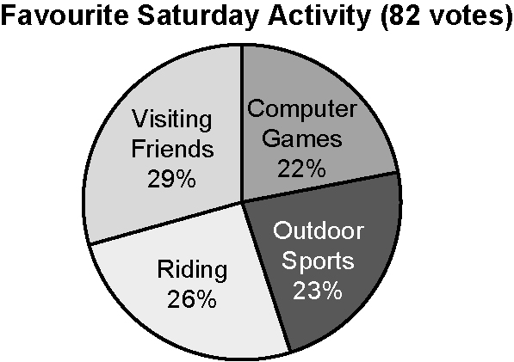
4.

5. Answers will vary. Example: Because the numbers are so close, the bar graph does a better job of displaying the differences between sectors. On the other hand, the circle graph emphasizes the closeness of each option.
6. 10 cm 7. 120 cm² 8.
9. 3 10.
BLM 7–4 Chapter 7 Problems of the Week
1. Neither shape will require more paint. Both will require 288 cm² of paint to cover.
2. In a right triangular prism, any pair of opposite faces can be referred to as the bases, since they are congruent. A right triangular prism has two different uses of the words base and height. The triangular ends of the prism are referred to as bases of the prism. The height of the prism is the distance between the triangular bases. The other use of base refers to the actual triangles themselves, which have base and height measurements.
3. Students can measure the diameter (and calculate the radius), or calculate the radius from the circumference of the circle.
a) The cylinder with a height of 28 cm has a volume of 1040.9 cm³. The cylinder with a height of 21.6 cm has a volume of 1349.1 cm³.
b) Students may be surprised that the cylinder with the shorter height had a greater volume. Explanations will vary. Ask the following questions: Is this always true? Does a shorter side on a piece of paper when rolled into a cylinder always have more volume than a longer side? When would the cylinders be of equal volume?
4. (8 cm × 9 cm × 10 cm) − (4 cm × 4.5 cm
× 5 cm) = 720 cm³ − 90 cm³ = 630 cm³. The volume not occupied by the solid block is 630 cm³.
5. Total surface area = 2072.4 cm². She needs 6.4 containers of paint, which when rounded to
a whole number, is 7 containers.
6. (1.5 m − 0.25 m) × 3 m × 4 m = 15 m³;
15 m³ ÷ 0.5 m³ = 30. It will take 30 wheelbarrow loads to fill the planter.
Note: #1 and #5 are included as they require students to distinguish between area and volume.
BLM 7–5 Section 7.1 Extra Practice
1. a) 5000 cm³ b) 7500 cm³ c) 4760 cm³
2. a) 4608 cm³ b) 4608 cm³
c) It is the same box (same dimensions).
The orientation has been changed.
3. a) 9 cm b) 5 cm c) 1 cm 4. 12.5 cm
BLM 7–6 Section 7.1 Math Link
1., 2. Sketches will vary. Ensure that the sketch is reasonable.
3. b) Answers may vary. Example: If three walls, the long wall should be about 2 m and the short walls should each be at least 0.75 m.
4. Answers will vary depending on dimensions and number of walls. Example:

Wall | Dimensions | Volume
Long wall | 2 m × 0.48 m² | 0.96 m³
Short wall | 1 m × 0.48 m² | 0.48 m³
Total volume of concrete needed = 0.96 + (2 × 0.48)
= 0.96 + 0.96
= 1.93m³
It would take 1.92 m³ of concrete to build the walls.
BLM 7–7 Section 7.2 Extra Practice
1. a) 1 cm³ b) 1953.125 cm³ c) 2744 cm³
2. a) 14 cm³ b) 4250 cm³ c) 10 125 cm³
3. a) 1296 cm³ b) 250 cm³ c) 480 cm³
4. a) 9 cm² b) 144 cm² c) 1 cm²
BLM 7–8 Section 7.2 Math Link
1. rectangular prism
2. 320 112 cm³ or 0.32 m³
3. 3 841 344 cm³ or 3.84 m³
4. 7 682 688 cm³ or 7.68 m³
BLM 7–9 Section 7.3 Extra Practice
1. a) 9878.44 cm³ b) 25.12 cm³
c) 81.3888 = 81.4 m³
2. a) 339.12 cm³ b) 6.28 m³ c) 98.125 cm³
3. a) 4 cm b) 7 cm c) 13 cm 4. 3.14 m³
5. Volume of original cylinder = 2813.44 cm³. Avery doubles the height: V = 5626.88 cm³. Monica doubles the radius: V = 11 253.76 cm³. Avery is correct. If you double the radius, you quadruple the volume.

BLM 7–10 Section 7.3 Math Link
1. a), b) Sketches will vary. Ensure that dimensions are reasonable.
c) Volume of top will depend on dimensions.
10 cm thickness = 0.1 m. Example: 1 m × 1 m
× 0.10 m = 0.1 m³
d) Volume of base will depend on height. 60 cm diameter = 0.60 m. Example: 3.14 × 0.30 m
× 0.30 m × 0.6 m = 0.17 m³
2. a), b) Sketches will vary. Ensure that dimensions are reasonable.
c) Volume of top will depend on dimensions.
10 cm thickness = 0.1 m. Example: 3.14 × 0.7 m
× 0.7 m × 0.10 m = 0.15 m³
d) Volume of base will depend on height. 60 cm diameter = 0.60 m. Example: 3.14 × 0.30 m
× 0.30 m × 0.6 m = 0.17 m³
3. a) You will need the answers for #1c) and d) and #2c) and d) to determine the total volume of both tables.
b), c) Total volumes will vary depending on dimensions chosen.
BLM 7–11 Section 7.4 Extra Practice
1. a) 8 cubes b) 24 cubes
c) 2 layers d) 48 cubes
e) Answers will vary. Example: All of the dimensions are divisible by 4. Since the cube is
4 cm square, it will fit evenly into the space.
2. 3456 cm³ 3. 6024.38 cm³
4. a) 9 cans
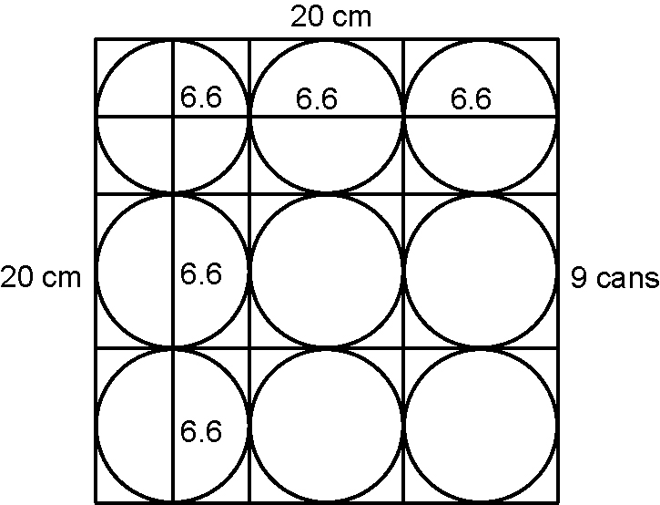
b) 4080 cm³ ÷ 341.946 cm³ = 11.9 cans
c) The calculation in part b) does not take into account the empty space because the cans are cylindrical and the box is a rectangular prism.

BLM 7–12 Section 7.4 Math Link
1., 2. Sketches and dimensions will vary. Ensure that they are reasonable. Ask students who have difficulty with one of the shapes to do the calculations for that shape of the planter.
3. Volumes will vary depending on dimensions.
4. b) Ensure that students correctly list the dimensions. Remind them that all the walls, including the bottom, are 7 cm thick.
c) Volumes will vary depending on dimensions. This volume should be smaller than that in #3.
5. a) subtraction
b) Volumes will vary depending on dimensions.
6. Volumes will vary depending on dimensions. Ensure that students subtract 2 cm from the inside depth of the planter before calculating.
BLM 7–13 Chapter 7 Test
1. C 2. D 3. C 4. C 5. A
6. Ensure that students have the units correct as well as the calculations.
a) 8 m² b) 565.2 mm³ c) 216 cm³
d) 429.3 cm³ e) 78.5 m² f) 7 cm g) 46.2 km²
7. 72 cm³
8. 399.115 cm³. Some students may ask about the volume of the ice cubes above the surface of the juice. Suggest that they research the problem and figure it out. Otherwise, assume there is no ice above the juice surface.
9. 2.876 m³
10. a) 178 038 cm³ b) 0.18 m³
11. 84.23 cm³
BLM 7–14 Chapter 7 Wrap It Up!
Answers will vary depending on the dimensions chosen for each item. Ensure that the dimensions are reasonable for each item.

