Chapter 8 Math Link Introduction
This worksheet will help you with the Math Link introduction on page 285.

Integer Chips


In your student resource, a red chip represents the value of +1 and a blue chip represents the value of −1. On worksheets, a chip with a + sign on it represents the value of +1. A chip with a − sign on it represents the value of −1.

A zero model consists of one positive chip and one negative chip: (+1) + (−1) = 0

Example:

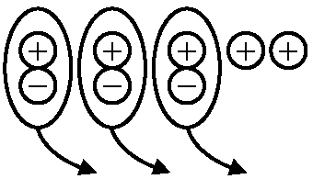
The model represents (+5) + (−3) = +2

Number Lines
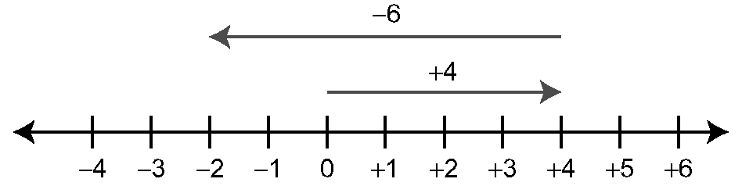
The number line models (+4) + (−6) = −2.


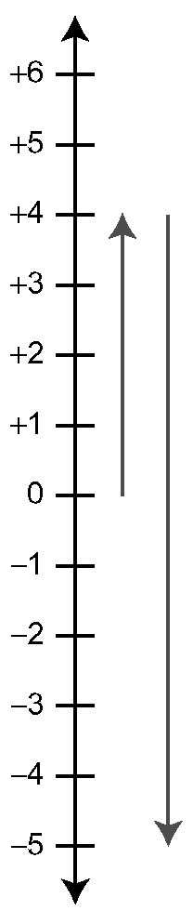
1. The diagram models a starting temperature
of −3 °C and an increase of 8 °C.
a) How does the diagram model the situation?
b) What is the final temperature? Using the diagram
above, show how you know.

2. The diagram models a starting temperature of
4 °C and a decrease of 9 °C.
a) How does the diagram model the situation?
b) What is the final temperature?
Using the diagram above, show how you know.
c) Draw a diagram using integer chips to model the
same situation. Include an explanation for your diagram.

3. Suppose a temperature change from 5 °C to −15 °C occurs
over a 4-h period.
a) What is the total change of temperature over the 4 h?
b) What operation would you perform to determine the change per hour?
c) Find the temperature change per hour.

