Represent Quantities with Integers
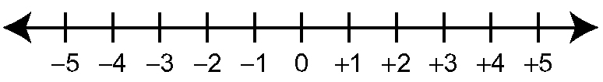
Integers include positive and negative
whole numbers and zero.
An integer is any of the numbers
…, −3, −2, −1, 0, +1, +2, +3, … .


Integer chips are coloured disks that represent integers. A represents +1, and a represents −1.
• If you climb five steps, this amount can be represented by the integer +5.
• If you descend ten steps, this amount can be represented by the integer –10.

1. Use an integer to represent each quantity. Explain your reasoning.  a) an increase of 3%  b) 20 m below sea level  c) a drop of 8 °C  d) 15 marks higher | 2. Suppose you win a prize of $15. Use an integer to describe what happens  a) from your point of view  b) from the point of view of the person giving the prize

Adding Integers
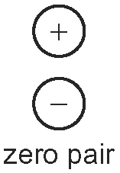


A zero pair includes one and one .
A zero pair represents zero.
Integer addition can be modelled using integer chips or diagrams.

3. Use the diagram to complete each addition statement.
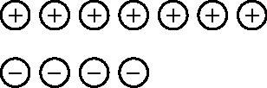
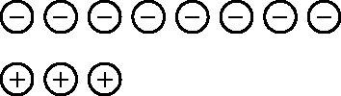
a) (+7) + (−4) = b) (−8) + (+3) =

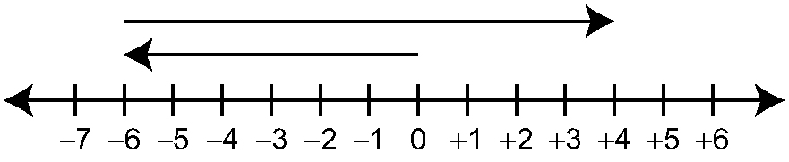
4. Use the diagram to complete each addition statement.

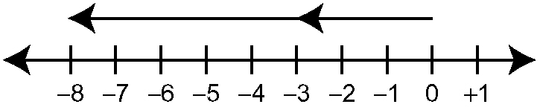
a)

(−3) + (−5) =

b)

(−6) + (+10) =

5. Complete each addition statement.
a) (+4) + (+5) = b) (−7) + (−7) =
c) (+6) + (−9) = d) (−2) + (+8) =

Subtracting Integers

Integer subtraction can be modelled using integer chips or diagrams.
Any integer subtraction can be completed by adding the opposite integer.
(+5) − (−4) = (+5) + (+4)
= +9

6. Use the diagram to complete each subtraction statement.

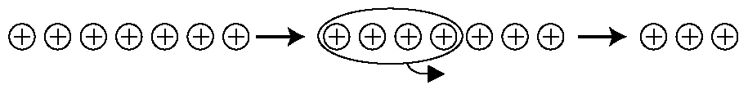
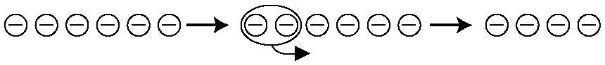
a) b)
(+7) − (+4) = (−6) − (−2) =

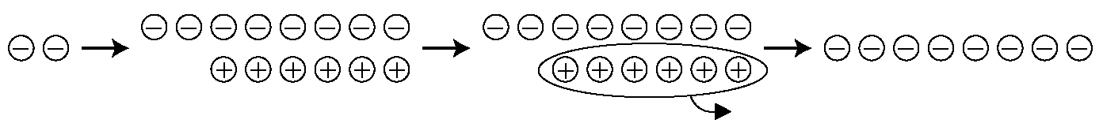
c)

(−2) − (+6) =

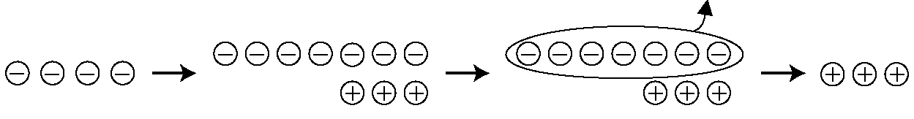
d)

(−4) − (−7) =

7. Complete each statement.  a) (+4) − (+7) = (+4) +  b) (−5) − (−2) = (−5) +  c) (−8) − (+8) = (−8) + | 8. Subtract.  a) (+6) − (+1) b) (−3) − (+5)  c) (+2) − (−2) d) (−3) − (+2)  e) (−6) − (−9) f) (+4) − (−1)

Order of Operations

The correct sequence of steps for a calculation follows the order of operations shown.
8 ÷ 4 + (3 + 2) × 6 − 7 Do brackets first.
= 8 ÷ 4 + 5 × 6 − 7 Multiply and divide from left to right.
= 2 + 30 − 7 Add and subtract from left to right.
= 25

9. Calculate.  a) 8 + 6 × 5 − 1  c) 3 × (7 − 2) + 16 ÷ 4 | b) 24 ÷ 6 + 18 ÷ 2  d) (4 + 2) ÷ 6 + 6 × 3 − 3

