Chapter 8 Warm-Up
Section 8.1

1. Calculate the volume of the following right rectangular prism. h = 7 cm
area of base = 24 cm²
2. Calculate the volume of the right prism.
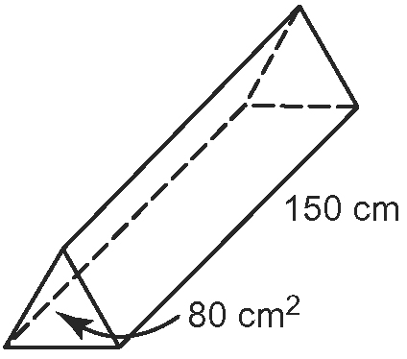
3. Maple syrup is being shipped in a cylindrical box with a height of 20 cm and a radius of 5 cm. What is the approximate volume of the box?
4. Calculate.
5. Calculate. 5 ×

Mental Math
6. A Japanese beetle has as many legs as a spider. Which has more legs? How do you know?
7. When you divide by 3, will your answer be greater than, less than, or equal to ? Explain.
8. When you divide by 1, will your answer be greater than, less than, or equal to ? Explain.
9. When you multiply a proper fraction by a natural number, will your answer be greater than, less than, or equal to the natural number? Explain.
10. When you multiply a proper fraction by 1, will your answer be greater than, less than, or equal to the natural number? Explain.

Section 8.2

1. Write as a repeated addition. (+5) × (−4)
2. What multiplication statement does this set of diagrams represent?
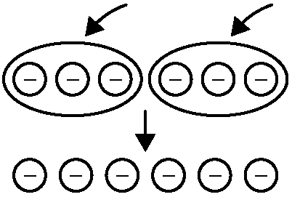
3. What multiplication statement does this set of diagrams represent?
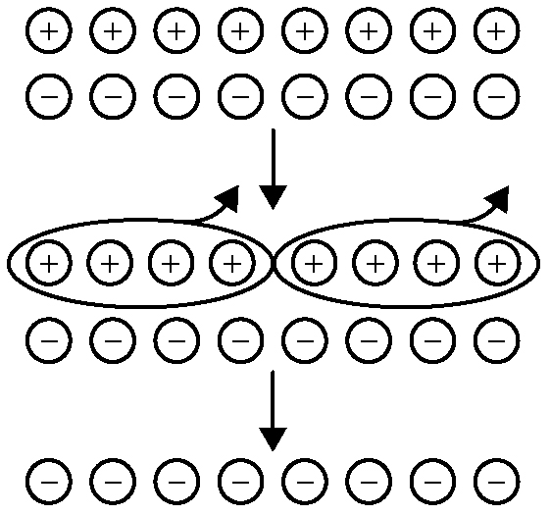
4. Calculate. (−2) × (−6)
5. Calculate. (−5) × (+3)

Mental Math
6. When you divide of a pie into three servings, will each serving be greater than, less than, or equal to ? Explain.
7. When you multiply two proper fractions, is the product greater than, less than, or equal to either of the common fractions? Explain.
8. When you divide a natural number by a proper fraction, will your answer be greater than, less than, or equal to the original number? Explain.
9. When you divide a natural number by a mixed number, will your answer be greater than, less than, or equal to the original number? Explain.
10. Show as a fraction in lowest terms.

Section 8.3

For #1 to #4, estimate and then calculate each product.
1. (+7) × (−11)
2. (+95) × (+30)
3. (−14) × (−11)
4. (+98) × (−6)
5. Calculate. 3 ÷ 2

Mental Math
6. What is 2.5% of $5000?
7. What is 3.25% of $400?
8. What is 135% of 44?
9. What is 250% of 64?
10. Estimate the amount of a 19% discount on $45.

Section 8.4

1. a) List two opposite integers.
b) Explain how you know they are opposite integers.
2. Copy and complete the division statement shown by the integer chips. (−9) ÷ (−3) =
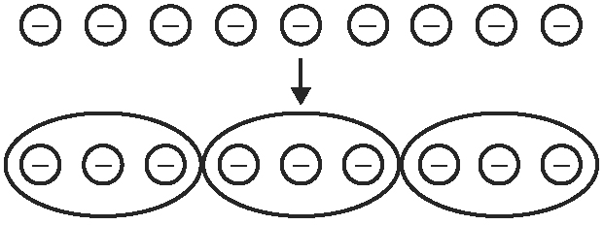
3. Draw integer chips to show
(−10) ÷ (+5).
4. Calculate. (+4) ÷ (−4)

5. a) Sketch a net for the cylinder.
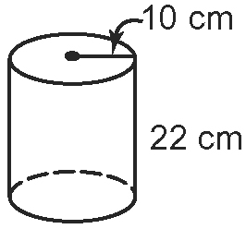
b) Calculate the approximate surface area of the cylinder.
Mental Math
6. Estimate the square root of 35 to the closest whole number.
7. Estimate the square of 9.8.
8. Estimate the square root of 90 to the closest whole number.
9. What is the square root of 64?
10. What is the square of 11?

Section 8.5

1. Use a number line to determine the quotient. (−21) ÷ (−7)
2. Calculate. (+85) ÷ (−5)
3. Calculate. (−24) ÷ (+8)
4. Copy and complete.
(+81) ÷ = (+9)
5. Calculate the surface area of the cylinder to the nearest cm².
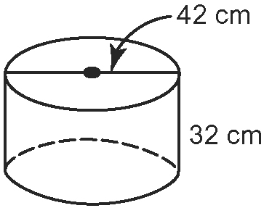

Mental Math
6. Estimate the circumference of a circle with a diameter of 40 cm.
7. Estimate the circumference of a circle with a radius of 40 cm.
8. Estimate the area of a circle with a diameter of 20 cm.
9. Estimate the area of a circle with a radius of 20 cm.
10. Is this a right triangle? Explain.
