Section 8.1 Extra Practice
1. Write each repeated addition as a multiplication statement, then calculate the answer. Example: (+4) + (+4) = (+2) × (+4) = +8

a) (+5) + (+5) + (+5) + (+5) = ____ × ____ = ____
b) (−9) + (−9) + (−9) = ____ × ____ = ____
c) (−2) + (−2) +(−2) +(−2) + (−2) = ____ × ____ = ____
d) (+3) + (+3) = ____ × ____ = ____

2. What multiplication statement does each set of integer chips represent?

Example: (+2) × (+3) = +6


a) b)



c) d)


3. a) This is an example of ____________________.


b) This is an example of ____________________.

4. What multiplication statement do the following zero pairs model?
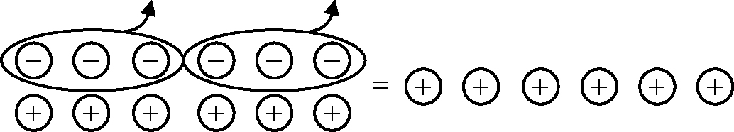
Example:
(−2) × (−3) = +6

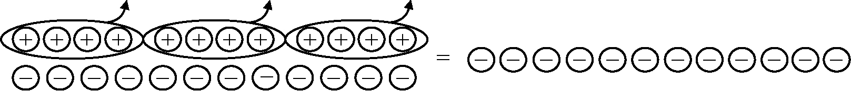
a)

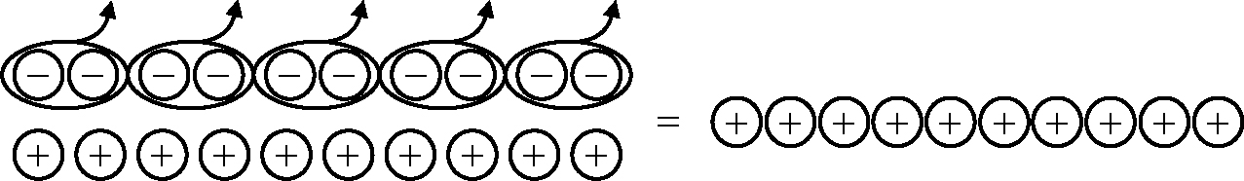
b)

