Section 8.2 Extra Practice
1. What multiplication statement does each diagram represent?
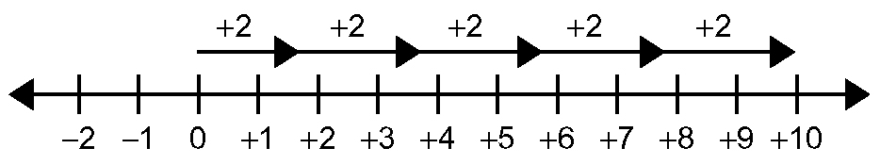
a)

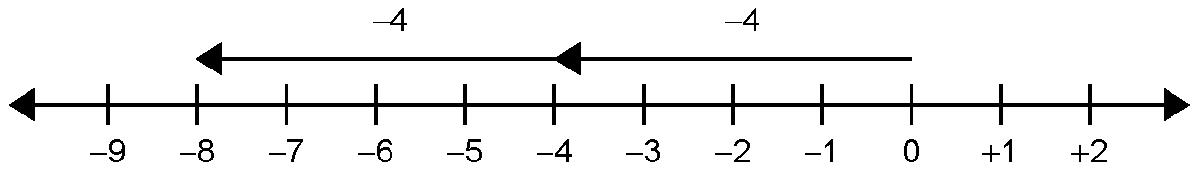
b)

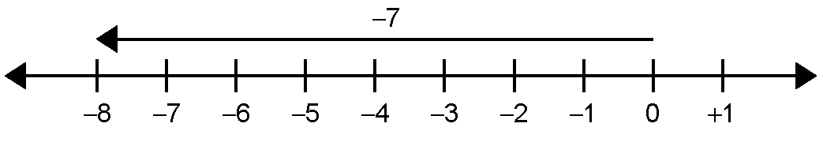
c)

2. Calculate.
a) (+12) × (+3) = ____ b) (−8) × (−6) = ____
c) (−9) × (+7) = ____ d) (−10) × 0 = ____

3. The product of two integers is −20. List all the possible multiplication statements to show this.

4. In hockey, a plus (+) is awarded every time you are on the ice for a goal your team scores and a minus (−) is given when you are on the ice when the other team scores. For eight straight games, Cassie has been on the ice when the opponents scored two goals. What is her plus/minus (+/−) score?

5. The sum of two integers is (−8). Their product is (+7). What are the two integers?

6. Write a word problem that you can solve using the expression (−3) × (−10).

