Section 8.3 Extra Practice
1. What division statement does each of the following diagrams represent?
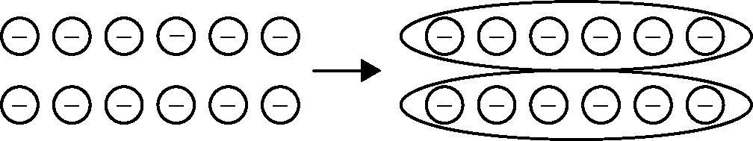
a)

____________________

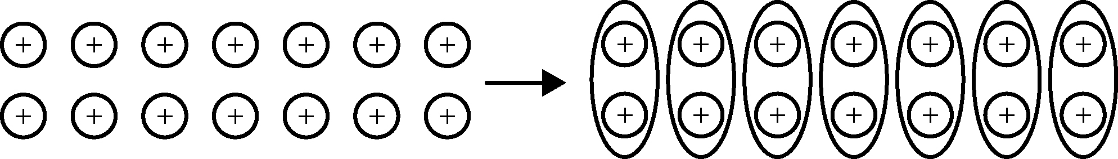
b)
____________________

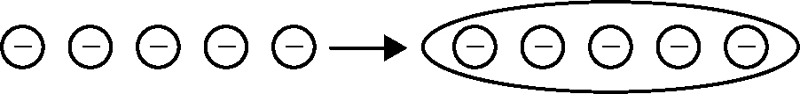
c) ____________________

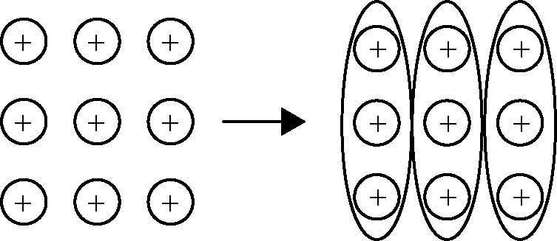
d)

____________________

2. What colour of integer chips would you use to model each division statement?
a) (×8) ÷ (−4) ____________________
b) (+9) ÷ (+3) ____________________
c) (−10) ÷ (+2) ____________________

3. In Winnipeg, the temperature at 10 p.m. was −16 °C. At 1 a.m. the temperature was −25 °C.
a) How many degrees did the temperature drop? ____________________
b) How many degrees per hour did the temperature drop? ____________________

4. a) How do you show zero using integer chips?

b) How could you show 0 divided by 2 using integer chips?

