Section 8.4 Extra Practice
1. What division statement does each of the following diagrams represent?

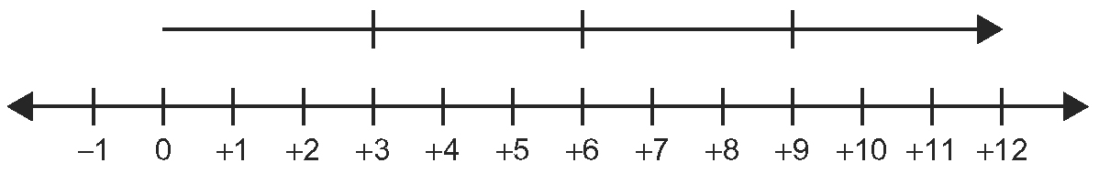
a)

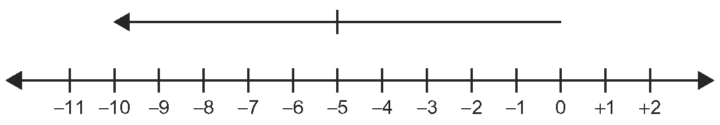
b)

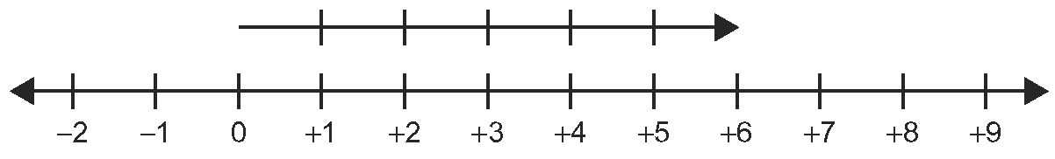
c)

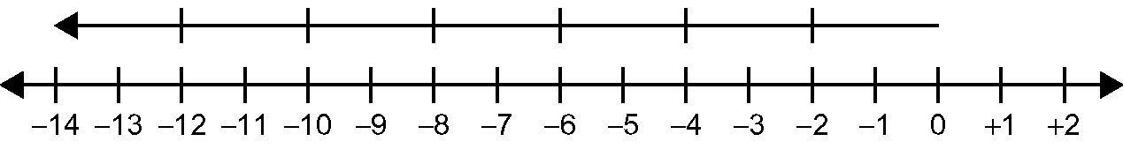
d)

2. Tell whether the resultant quotient is positive or negative.
a) (negative number) ÷ (positive number) ____________________
b) (positive number) ÷ (positive number) ____________________
c) (negative number) ÷ (negative number) ____________________
d) (positive number) ÷ (negative number) ____________________

3. Calculate.
a) (+56) ÷ (−7) = ____ b) (−45) ÷ (−15) = ____
c) (−36) ÷ (+12) = ____ d) (+60) ÷ (+10) = ____

4. Divide the dividend –8 by as many different integers as possible. Each quotient must be an integer. List all the possible division statements.

5. For each of the following questions, there are two different pairs of two integers that will work.
a) Which two integers have a product of +20 and a quotient of +5?

b) Which two integers have a product of −18 and a quotient of −2?

c) Which two integers have a product of +4 and a quotient of +4?

