Chapter 8 Test
Do not use a calculator for this test.

For #1 to #5, select the best answer.

1. Which multiplication does the diagram represent?
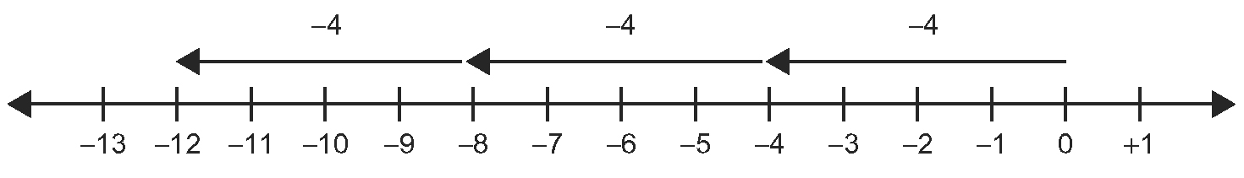
A (−4) × (+3) B (−3) × (−4) C (−3) × (+4) D (+4) × (+3)

2. Which division could the diagram represent?
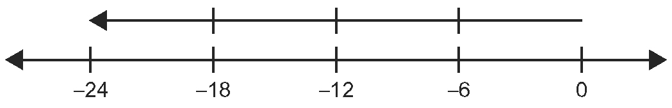
A (+24) ÷ (+4) B (+24) ÷ (−4) C (−24) ÷ (+6) D (−24) ÷ (−6)

3. What is the final value of this multiplication question?
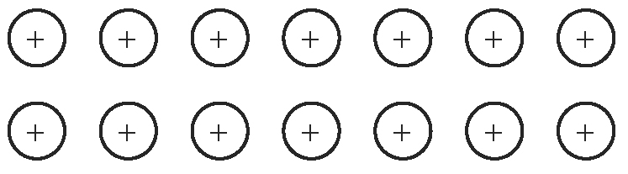
A +14 B +7 C +2 D −14

4. What is the final value of this division question?
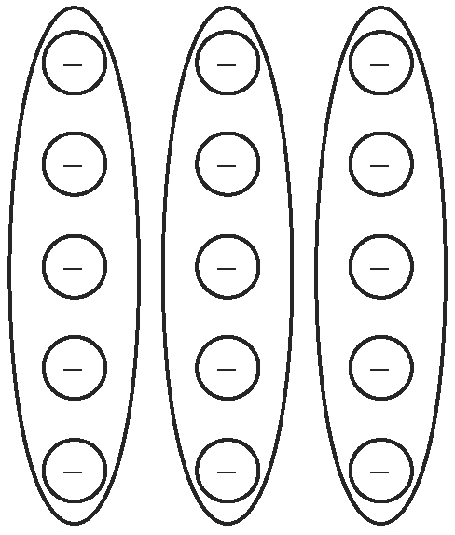
A +5 B −3 C −5 D −15

Short Answer
5. Water freezes at 0 °C. If water at 97 °C is cooled at a rate of 6 °C per minute, will it be frozen in 16 min? Show a mathematical statement and all your work.
6. In your own words, state the sign rules that you would apply to decide whether the answer is positive or negative when you calculate each of the following:
a) (+12) ÷ (+3)
b) (−5) × (+4)
7. A 123-step staircase starts at ground level and leads to the bottom of a cave. If Tiesha starts at the bottom of the cave and walks up three steps per stride, how many strides must she make to reach ground level? Show a mathematical statement and all your work.
8. Estimate each product and quotient, then calculate.
a) (−210) ÷ (+7) b) (−36) × (−8)
c) (+492) ÷ (−3) d) (+9) × (−15)
e) (−312) ÷ (−4) f) (−28) × (+11)
9. Calculate.
a) (+7) × (−3) − (−25) ÷ (−5) b) (−39) − (+4) ÷ (+2) + (+53)
c) (−56) + (−9) × (+3) − (−76) d) (+42) ÷ (−7) + (−8) × (+2)

Extended Response
10. A hot-air balloon begins at ground level. It then moves up at a rate of
5 m/min. After 17 min, it moves down at a rate of 3 m/min for 6 min. Then, it moves up at a rate of 11 m/min. How high above the ground is the hot-air balloon after 1 h? Show all your work.
11. Using each of the integers (−2), (+8), (−6), and (+1) at least once, create four different expressions that include +, −, ×, and ÷ at least once and result in an answer between (−10) and (+10).
12. Water begins leaking into a boat at 3 L/min. After 5 min, a bilge pump begins pumping water out of the boat at 4 L/min. Ten minutes after the pump starts, it begins to rain steadily, which fills the boat at a rate of
2 L/min. How much water is in the boat after half an hour if the rates remain constant? Show all your work.

