Chapter 8 Wrap It Up!
This worksheet will help you with the Wrap it Up! on page 321.
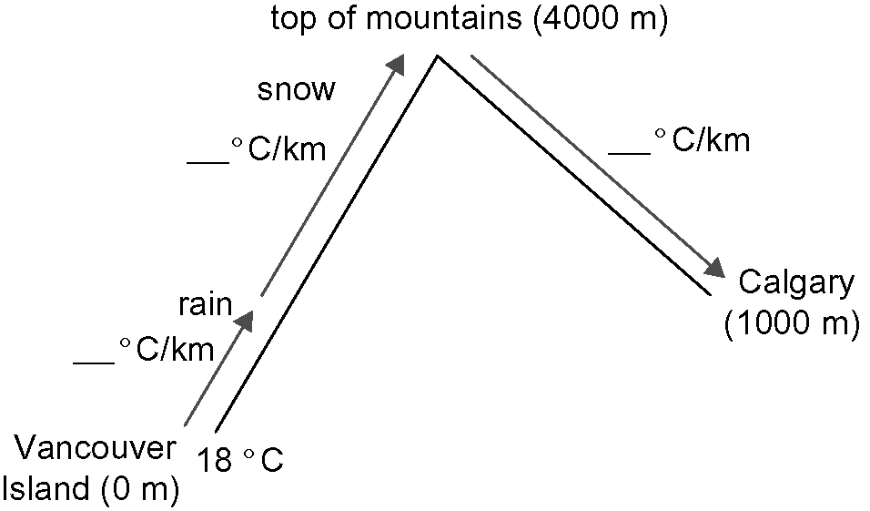
The diagram models the
temperature changes as the
air travels from Vancouver
Island to Calgary.

1. Fill in the blanks on the diagram.

2. What is the air temperature on Vancouver Island?

3. What is the temperature change per kilometre of altitude for the first 1 km above Vancouver Island?

4. What is the temperature at an altitude of 1 km above Vancouver Island?

5. What is the temperature change per kilometre of altitude for the rest of the way up the mountains?

6. How many kilometres in altitude is it to the top of the mountains above Vancouver Island?

7. What is the temperature at the top of the mountains?

8. What is the temperature change per kilometres of altitude as the air flows down the mountains?

9. How many kilometres in altitude is it from the top of the mountains to Calgary?

10. What is the temperature of the air when it reaches Calgary?

11. Use your understanding of integer multiplication and division to show how you could determine the answer for #10 without using a diagram.

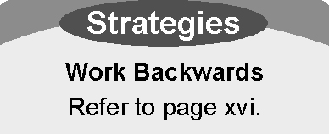
12. Suppose the temperature when the air reaches Calgary
is 30 °C.
a) What was the starting temperature on Vancouver Island?
Perform the steps outlined in #2 to #10 in reverse order. Use inverse operations.
b) Check your answer. Show your steps below.

