Chapter 8 BLM Answers

BLM 8–1 Chapter 8 Math Link Introduction
1. a) Answers will vary. Example: Three negative chips show a starting temperature of –3 °C and eight positive chips show an increase of 8 °C.
b) 5 °C. Diagram should show a circle around each of three zero pairs.
2. a) Answers will vary. Example: The first arrow shows a starting temperature of 4 °C and the second arrow shows a decrease of 9 °C.
b) −5 °C
c) Four positive chips represent the starting temperature of 4 °C and nine negative chips represent a decrease of 9 °C.
3. a) −20 °C b) division c) −5 °C
BLM 8–2 Chapter 8 Get Ready
1. Explanations will vary.
a) +3%. An increase is a positive integer.
b) –20 m. If sea level is 0, below sea level should be a negative integer.
c) –8 °C. The temperature is going down. That suggests a negative integer.
d) +15. The mark went up. That suggests a positive integer.
2. a) You are now +$15.
b) The person giving the prize is now –$15.
3. a) +3 b) –5 4. a) –8 b) +4
5. a) +9 b) –14 c) –3 d) +6
6. a) +3 b) –4 c) –8 d) +3
7. a) –7 b) +2 c) –8
8. a) +5 b) –8 c) +4 d) –5 e) +3 f) +5
9. a) 37 b) 13 c) 19 d) 16
BLM 8–3 Chapter 8 Warm-Up
Section 8.1
1. 168 cm³ 2. 12 000 cm³ 3. 1570 cm³
4. = 5. = 1
6. The spider. Answers will vary. Example: The Japanese beetle has a fraction of the number of legs the spider has.
7. Less than. Answers will vary. Example: You are cutting the fraction into three pieces. Each piece will be smaller than the original fraction.
8. Equal to. Answers will vary. Example: The value of any number divided by 1 does not change.
9. Less than. Answers will vary. Example: You are taking a fraction of the number.
10. Equal to. Answers will vary. Example: The value of any number multiplied by 1 does not change.
Section 8.2
1. (−4) + (−4) + (−4) + (−4) + (−4)
2. (+2) × (−3) = −6 3. (−2) × (+4) = −8
4. +12 5. −15
6. Less than. Answers will vary. Example: is being cut into pieces. Each piece will be smaller than what you started with.

7. Less than. Answers will vary. Example: You are finding a fraction of a fraction. The answer will be less than either fraction.
8. Greater than. Answers will vary. Example: You are trying to find out how many of the fraction will fit in a natural number, so the answer is greater than the number because the fractions are less than 1.
9. Less than. Answers will vary. Example: This is like dividing a natural number by more than 1, so the answer is less than what you started with.
10.
Section 8.3
1. ≈ −70; −77 2. ≈ 3000; +2850
3. ≈ 140; +154 4. ≈ −600; −588
5. 1 6. $125 7. $13 8. 59.4 9. 160 10. $9
Section 8.4
1. a) Answers will vary. Example: +4 and –4
b) Answers may vary. Example: They add to 0.
2. (−9) ÷ (−3) = +3
4. −1
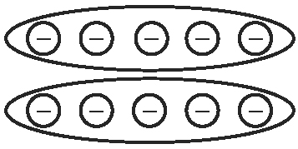
3.

5. a) Answers will vary. Example:
b) 2009.6 cm²

6. 6 7. 100 8. 9 9. 8 10. 121
Section 8.5
1. 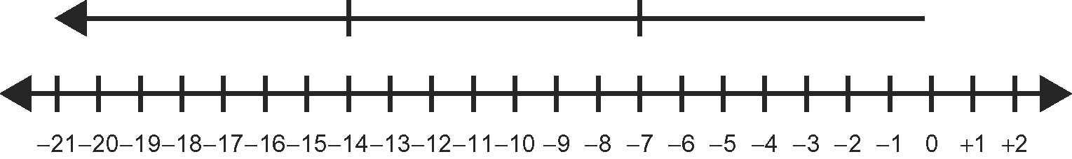
2. −17 3. −3 4. +9 5. 6990 cm²
6. ≈ 120 cm 7. ≈ 240 cm
8. ≈ 300 cm² 9. ≈ 1200 cm²
10. No. Answers will vary. Example: I know that it is not a right triangle because the area of the squares on the two smaller sides does not equal the area of the square on the longer side.
BLM 8–4 Chapter 8 Problems of the Week
1. −60 × 10, −10 × 60, −15 × 40, −40 × 15,
−20 × 30, −30 × 20, 12 × –50, −12 × 50,
−24 × 25, −25 × 24 2. −15 and 9
3. a) 24; 24(2) + 16(−3) = 0
b) Answers will vary. Example: Not fair. If you get three correct answers but guess two wrong, your mark is zero. This method of scoring is used to discourage students from guessing.

4. –14 5. Answers may vary. Examples:
(8 − 2) × [−4 − (−6)] = 12
(8 + 2) ÷ [−6 − (−5)] = −10
[8 + (−5)] × [2 − (−6)] = 24
[8 + (−6)] × [(−5) – (−4)] = −2
6. No. The answer is 4.
BLM 8–5 Section 8.1 Extra Practice
1. a) (+4) × (+5) = +20 b) (+3) × (−9) = −27
c) (+5) × (−2) = −10 d) (+2) × (+3) = +6
2. a) (+3) × (−2) = −6 b) (+4) × (+3) = +12
c) (+2) × (+5) = +10 d) (+1) × (−8) = −8
3. a) zero pair b) four zero pairs
4. a) (–3) × (+4) b) (–5) × (−2)
BLM 8–6 Section 8.2 Extra Practice
1. a) (+5) × (+2) = +10 b) (+2) × (−4) = −8
c) (+1) × (−7) = −7
2. a) +36 b) +48 c) −63 d) 0
3. (+1) × (−20); (+2) × (−10); (+4) × (−5);
(+5) × (−4); (+10) × (−2); (+20) × (−1)
4. (+8) × (−2) = (−16) 5. −1 and −7
6. Answers will vary. Example: Every time you go to the mall, you spend $10. If you change your mind three times and you don’t go to the mall (a non-occurrence or negative occurrence), then you don’t spend $10 (−$10). (−3) × (−10) = (+30)
BLM 8–7 Section 8.2 Math Link
1. a) negative b) −6 °C, −12 °C, –18 °C,
−24 °C, −66 °C c) –62 °C
2. a) 6 km b) +36 °C
3. Answers will vary. Example:
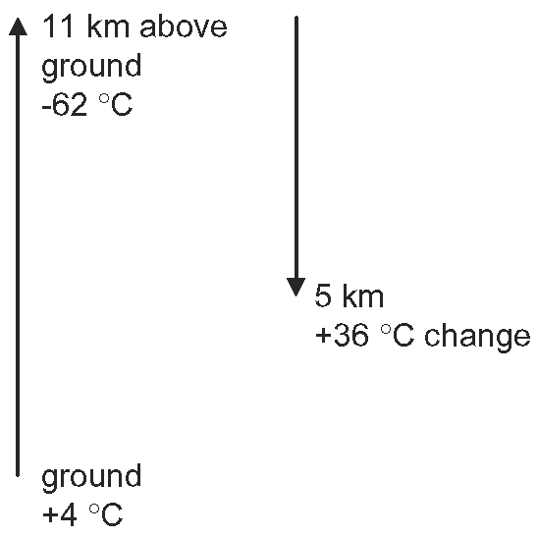
BLM 8–8 Section 8.3 Extra Practice
1. a) (−12) ÷ (+2) = −6 b) (+14) ÷ (+2) = +7
c) (−5) ÷ (+1) = −5 d) (+9) ÷ (+3) = +3
2. a) blue b) red c) blue
3. a) 9 °C b) 3 °C per hour
4. a) one blue and one red chip b) Answers will vary. Example: Show two zero pairs divided into two groups of one zero pair each.
BLM 8–9 Section 8.4 Extra Practice
1. a) (+12) ÷ (+3) = +4 b) (–10) ÷ (–5) = +2
c) (6) ÷ (+1) = +6 d) (−14) ÷ (–2) = +7
2. a) negative b) positive
c) positive d) negative
3. a) −8 b) +3 c) −3 d) +6
4. (−8) ÷ (+1) = −8; (−8) ÷ (−1) = +8;
(−8) ÷ (+2) = −4; (−8) ÷ (−2) = +4;
(−8) ÷ (+4) = −2; (−8) ÷ (−4) = +2;
(−8) ÷ (+8) = −1; (−8) ÷ (−8) = +1
5. a) −10 and −2; +10 and +2
b) +6 and −3; −6 and +3
c) +4 and +1; −4 and −1
BLM 8–10 Section 8.4 Math Link
1. 42 °C
2. a) −17 °C b) −23 °C c) −29 °C
d) −35 °C e) −41 °C f) −47 °C
g) −53 °C h) –59 °C i) −65 °C
3. 7 km 4. Answers will vary. Example: The
change of temperature is 42 °C; 42 ÷ 6 = 7.
BLM 8–11 Section 8.5 Extra Practice
1. a) −17 b) +9 c) +11
2. a) 49 yards b) 7 yards a carry
3. a) +6 b) +0.5
4. a) (+4) + (−2) ×[(+6) − (+1)] = −6
b) [(+4) + (−2)] × (+6) − (+1) = +11
c) [(+4) + (−2)] × [(+6) − (+1)] = +10
d) [(+4) + (−2) × (+6)] − (+1) = −9
BLM 8–12 Chapter 8 Test
1. A 2. D 3. A 4. C
5. 97 ÷ 6 = 16, with a remainder of 1.
After 16 min, the water will not be frozen.
6. Answers will vary. Example:
a) When dividing two integers, if the signs are the same then the answer is positive.
b) When multiplying two integers, if the signs are different then the answer is negative.
7. 123 ÷ 3 = 41. She has to take 41 strides to reach ground level.
8. Estimates will vary.
a) −30 b) 288 c) −164
d) −135 e) 78 f) −308
9. a) −26 b) 12 c) −7 d) −22
10. (+17) × (+5) + (−3) × (+6) + (+11) × (+37) = 474. The hot-air balloon will be 474 m above the ground after 1 h.
11. Answers will vary. Example:
(−2) + (+8) + (−6) × (+1) ÷ (+1) = 0
12. (+3) × (+30) + (–4) × (+25) + (+2) × (+15) = 20. There would be 20 L of water in the boat after half an hour.
BLM 8–13 Chapter 8 Wrap It Up!
1. −10 °C, −5 °C, +10 °C 2. 18 °C 3. −10
4. −10 + 18 = 8 °C 5. −5 °C 6. 4 km
7. −7 °C 8. +10 °C 9. 3 km 10. 23 °C
11. 18 + (−10) × 1 + (−5) × 3 + 10 × 3
12. a) Calculate:
30 − 10 × 3 − 3 × (−5) − 1 × (−10) = 25 °C
b) Check:
25 + (−10) × 1 + (−5) × 3 + 10 × 3 = 30 °C

