Describe Patterns in Words
Patterns can be described using words. When you describe a pattern,
tell what it is, where it starts, and how it changes.
• The pattern of letters a, c, e, … can be described as letters of the alphabet beginning with a and skipping one letter each time or increasing by two letters.
• The number pattern 6, 9, 12, … can be described as whole numbers that begin with 6 and increase by 3 or are multiples of 3.

1. Describe each pattern in words.
a) b, e, h, … b) p, n, l, … c) 15, 20, 25, … d) 9, 4, –1, …
Show Patterns in a Table

A café has small tables that seat
four people. Small tables can be
moved together to seat larger groups
as shown.
The information from this pattern can be shown in a table.
Number of Tables | 1 | 2 | 3
Number of Chairs | 4 | 6 | 8
You can describe the pattern as “the number of chairs begins at 4 and increases by 2 each time you add a table.”

2. For each pattern, make a table and then describe the pattern.
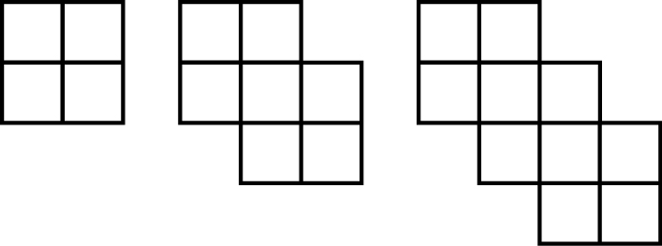
a)

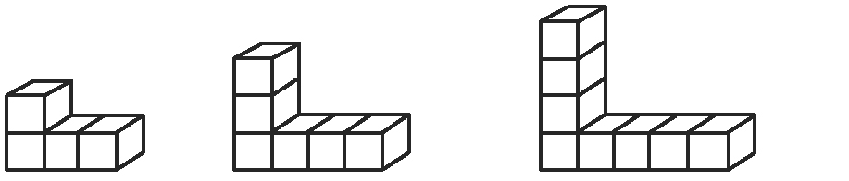
b)

Describe Patterns Using an Expression
There are three algae eaters and some guppies in a fish tank. If the number of guppies is represented by the variable g, the total number
of fish in the tank can be expressed as g + 3.

3. Write an expression for each scenario. Tell what your variable represents.  a) Shay has five boxes of pencils. Each box has the same number of pencils. How many pencils does he have in total? | b) A Winnipeg warehouse has  12 shipping cartons of DVDs. Each carton has the same number of DVDs. The cartons will go to four different cities. How many DVDs will go to each city?  c) Loree has a bag of candies. She gives seven candies to a friend. How many does she have left?
Use a Coordinate Grid
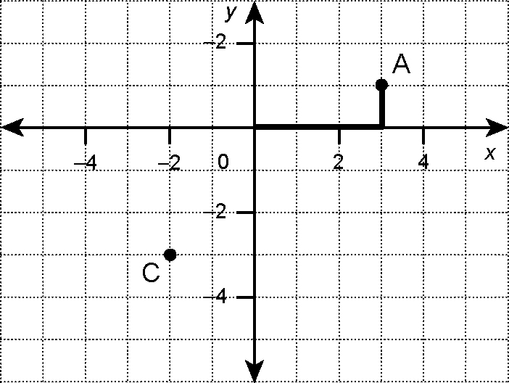
Points on a coordinate grid are described using ordered pairs written as (x, y). Point A can be described using the
ordered pair (3, 1).
• The first coordinate, or x-coordinate, is the
horizontal distance of point A from the y-axis.
• The second coordinate, or y-coordinate, is
the vertical distance of point A from the x-axis.
You can locate points by counting from the
origin (0, 0).

4. Use the above coordinate grid to answer the questions.  a) What are the coordinates for point C? | b) Label point F(0, 2). Describe the location of your point with reference to the origin.

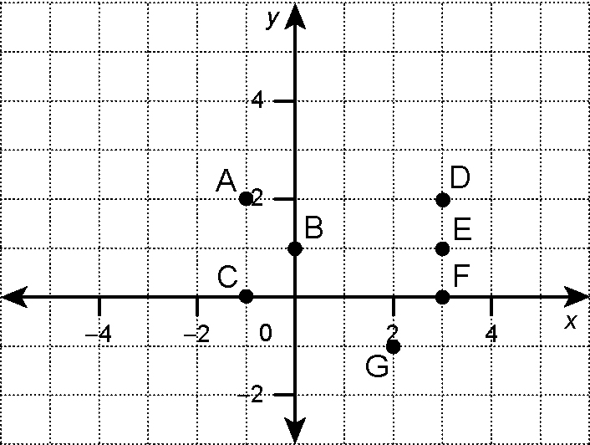
5. a) Which points on the grid to the right are
represented by each pair of values in the table?
x | –1 | 2 | 3
Y | 0 | –1 | 2

b) Make a table that shows the coordinates for
points A, B, and E.

