Chapter 9 Warm-Up
Section 9.1

1. Estimate and then calculate. Express your answers to one decimal place, where necessary.  a) (+26) × (−40)  b) (−149) ÷ (+14)  2. Calculate using the order of operations.  a) (−40) ÷ (−8) + (−8) ÷ (+2)  b) (+6) × [(+15) − (−3)] + (−4)  3. Over a five-year period, the number of grade 8s in a school decreased from 143 to 122. What was the mean change per year?  4. The mean of four integers is −4. What is the sum of the integers?  5. The books that the Wong family owns are shown on these graphs.  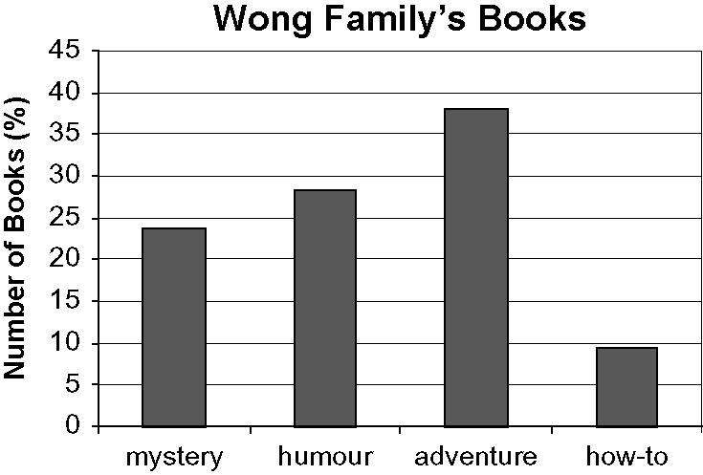  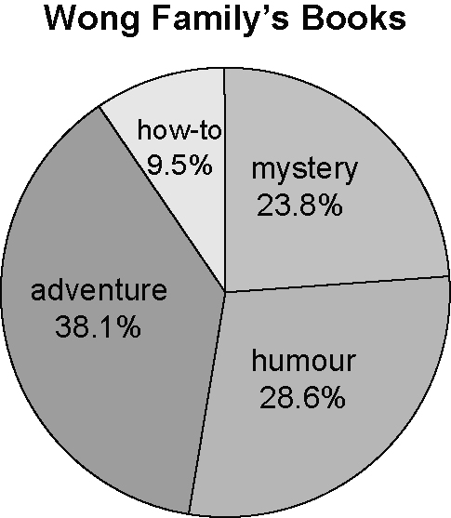 | a) Which graph can you use to determine the total number of books in the library? Explain.  b) Which graph would most help you calculate how to spend $100 on some new books for the Wong Family?  Mental Math  6.  7.  For #8 to #10, use this visual.  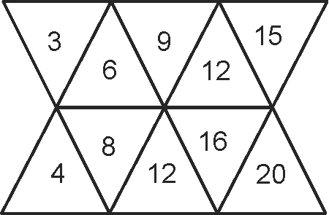  8. What is the ratio of odd to even numbers in the top row of triangles?  9. What is the ratio of odd to even numbers in the bottom row of triangles?  10. What is the ratio of odd to even numbers altogether?

Section 9.2

For #1 to #4, use this graph.  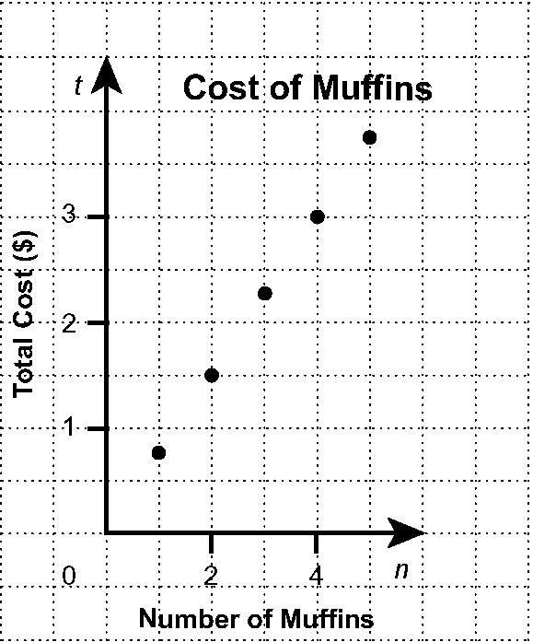  1. Describe patterns you see on the graph.  2. Make a table of values from the graph.  3. If the relationship continues, what is the cost of eight muffins?  4. Is it possible to have points between the ones on the graph? Explain.  5. Calculate the length of the unknown side. Show your thinking. Express your answer to a hundredth of a metre.  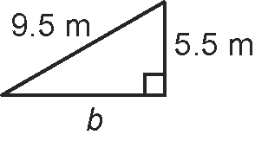 | Mental Math  6. Determine the square of each number.  a) 5 b) 15 c) 25  7. Determine each square root.  a) b) c)  8. Estimate each square root. Show your thinking.  a) b)  9. There were 200 worms in a compost pile. The population increased by 50% in each of two months. What was the population at the end of two months? Show your thinking.  10. Show as a decimal and as a percent:  a) 1 b)

Section 9.3

For #1 to #4, use these tables of values.  Table 1  Table 2  1. What is the pattern in the values for the first variable in each table?  2. What is the difference in consecutive values for the second variable in each table? Is the difference within each table the same?  3. Graph each set of ordered pairs. Which relations are linear?  4. How does your answer to #3 compare to your answer to #2?  5. The diagrams show the top, front, and side views of a tissue box. You rotate the box clockwise 90° to stand it on its end. Draw the new top, front, and side views.  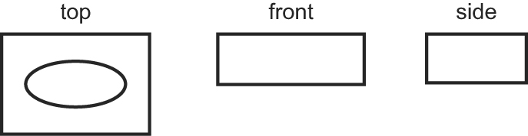 | Mental Math  For #6 to #10, show your thinking.  6. Estimate the surface area of a cylinder with a diameter of  2.2 cm and a height of 4.8 cm.  7. Estimate the volume of the cylinder in #6.  8. Estimate the surface area of the following triangular prism.  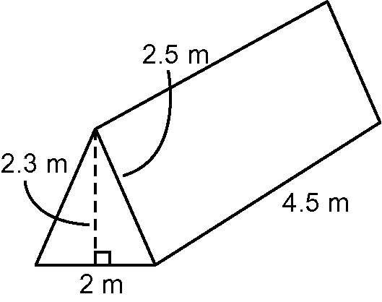  9. Estimate the volume of the prism in #8.  10. a) Estimate the volume of a  rectangular prism  4.5 m × 2 m × 2.3 m.  b) Explain why your answer is  different from your answer in  #9 when you used the same  measurements.
  s | 1 | 2 | 3 | 4
  t | 4 | 6 | 9 | 13
  a | 1 | 2 | 3 | 4
  b | 4 | 8 | 12 | 16

