Section 9.1 Extra Practice
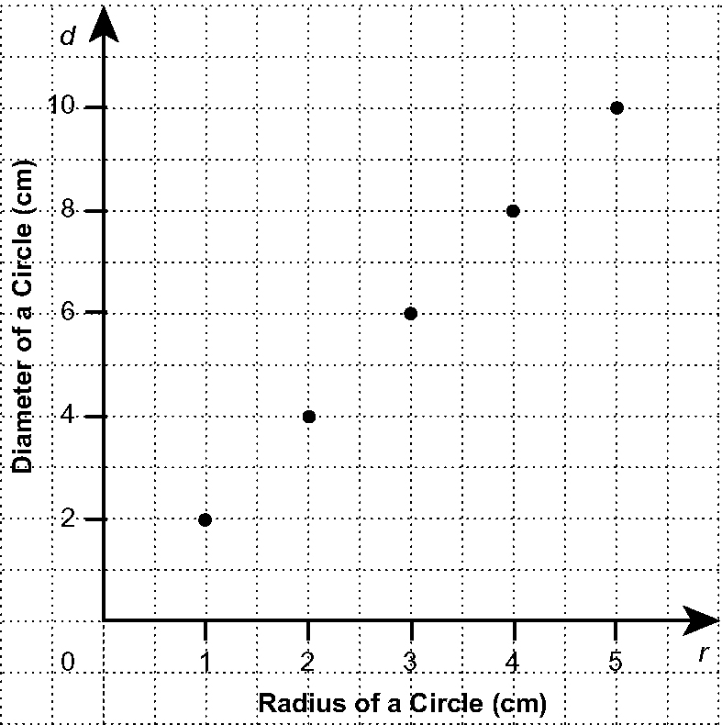
1. a) Make a table of values from the graph.
b) What is the diameter of a circle with
a radius of 8 cm?
c) What is the radius of a circle with a
diameter of 22 cm?
d) Is it reasonable to include a point on the
graph for r = 4.5 cm? Explain.

2. Nikki is making a graph of the data in the table of values:
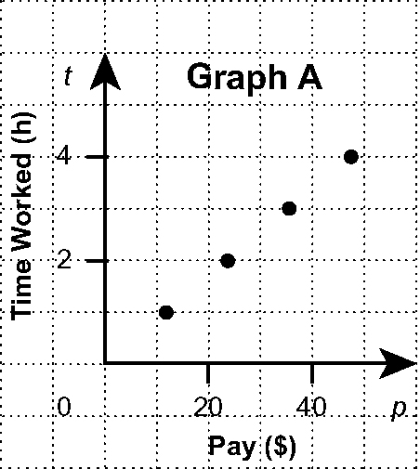
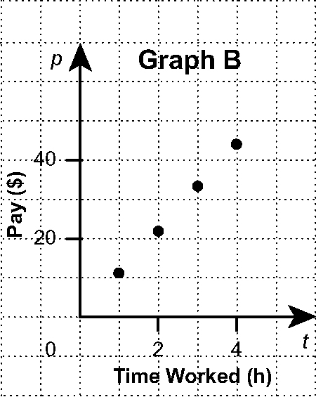
Time Worked,  t (h) | Pay,  P ($)
1 | 11
2 | 22
3 | 33
4 | 44

Does one of the graphs show the data from the table? Explain.

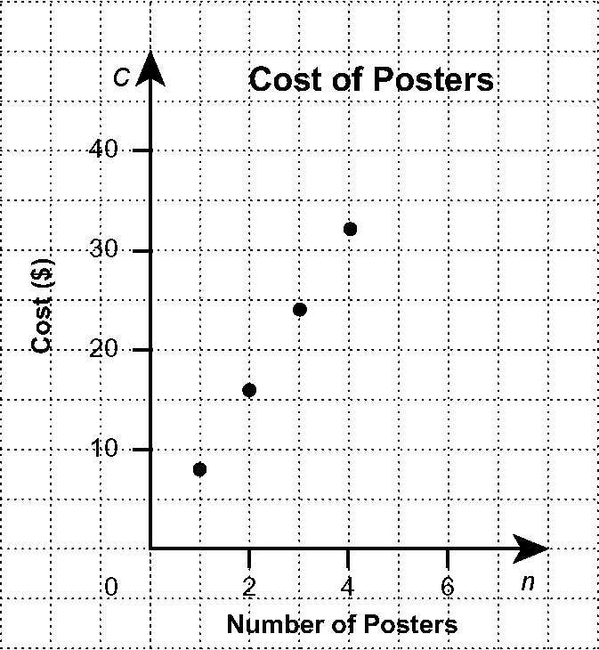
3. a) Copy the table of values into your notebook.
Look at the points on the graph to complete
the table of values.

Number of Posters, n | Cost, C ($)
1 | 8
2 | 16

b) What would be the cost of six posters?
c) Would it be reasonable to have points
between the ones on the graph? Explain.

