Section 9.1 Math Link
This worksheet will help you with the Math Link on page 341.

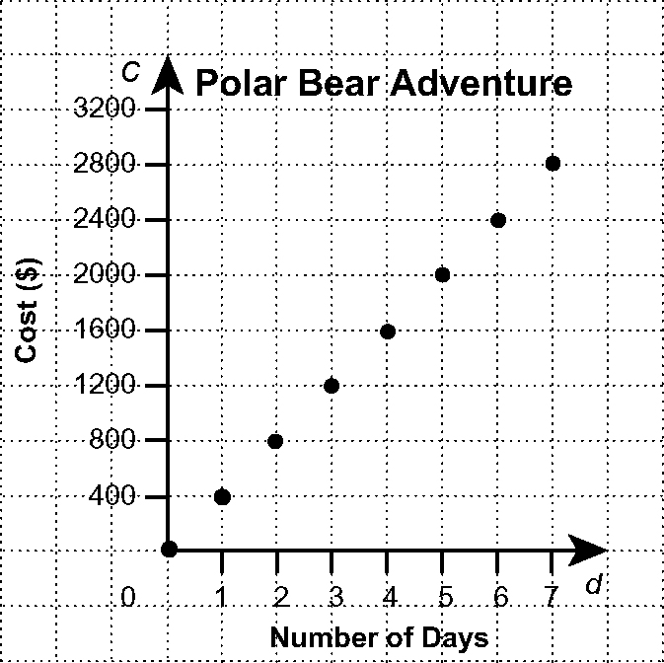
You are going on a polar bear adventure tour.
The graph shows the cost of the trip.

1. Describe any patterns that you see in
the graph.

2. Complete the first two columns of the following table of values by referring to the graph. The first two rows have been completed as an example.

Number of Days, d | Cost, C ($) | Cost of Deluxe Tour ($)
1 | 400 | 400 + 300 = 700
2 | 800 | 800 + 300 = 1100

3. a) If the pattern continues, what is the cost of a tour for eight days?
b) Enter this value in the table.

4. Suppose it is possible to upgrade to better accommodations for a one-time fee of $300 plus the regular $400 per day. Enter the cost per day for the deluxe tour into the third column of the table. The first two rows have been completed as an example.

5. a) How are the data for the two costs similar?
b) How are the data for the two costs different?

