Section 9.3 Extra Practice
1. Consider the linear equation y = 3x −1.
a) Make a table of values using x = −2, −1, 0, 1, 2.
b) Graph the ordered pairs from the table.
c) Use the equation to calculate y when x = 4.
d) For the point (x, −10), what is the value of x?

2. The graph below represents part of the linear relation y = .
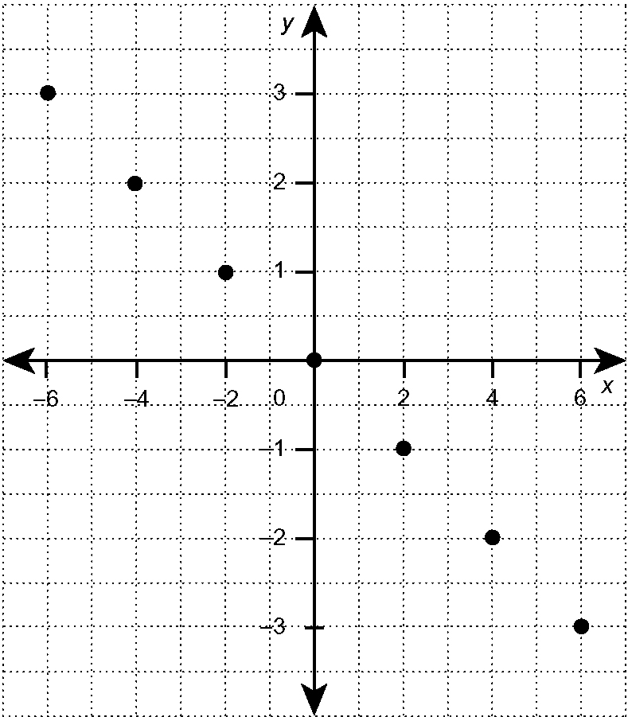

a) Use the graph to estimate y when x = −1.
b) Use the equation to calculate y when x = 16.
c) For the point (x, 3.5), estimate the value of x from the graph.

3. a) Graph the ordered pairs from the table of values.

x | 0 | 1 | 2 | 3 | 4
y | 0 | 1 | 4 | 9 | 16

b) Is this a linear relation? Use two different ways to explain your answer.

