Chapter 9 Test
For #1 to #5, select the best answer.

1. Which word describes y = x + 2?
A constant B equation C expression D variable

2. The table shows the number of lug nuts in relation to the number of tires. Which equation represents the linear relation?
A n = t + 5
B t = n + 5
C n = 5t
D t = 5n

Tires  (t) | Lug Nuts (n)
1 | 5
2 | 10
3 | 15
4 | 20

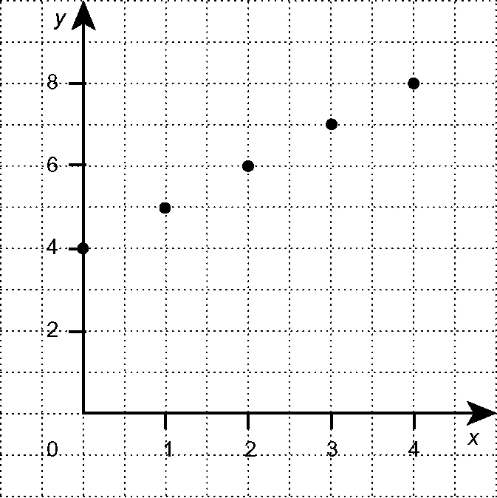
3. Which table of values represents the graph
shown?
A B C D
x | y |  | x | y |  | x | y |  | x | y
0 | 4 |  | 0 | 4 |  | 0 | 4 |  | 0 | 4
1 | 5 |  | 1 | 5 |  | 1 | 5 |  | 1 | 6
2 | 6 |  | 2 | 6 |  | 2 | 7 |  | 2 | 6
3 | 7 |  | 3 | 7 |  | 3 | 6 |  | 3 | 7
4 | 8 |  | 4 | 7 |  | 4 | 8 |  | 4 | 8

4. Which table of values represents the linear relation represented by the equation y = 2x − 3?
A B C D
x | y |  | x | y |  | x | y |  | x | y
0 | 3 |  | 0 | 3 |  | 0 | −2 |  | 0 | −3
1 | 5 |  | 1 | 1 |  | 1 | −1 |  | 1 | −1
2 | 1 |  | 2 | 0 |  | 2 | 0 |  | 2 | 1

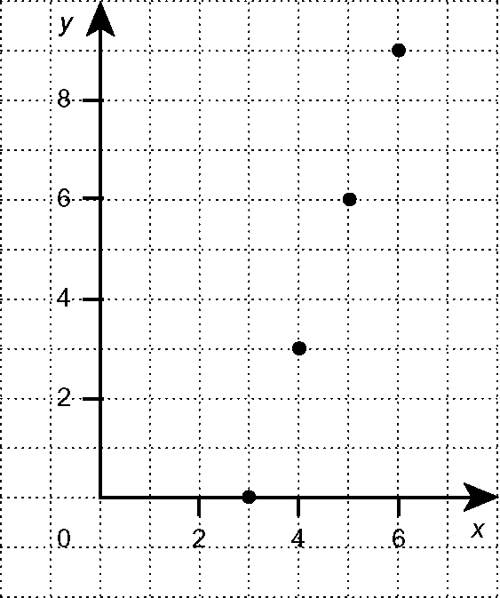
5. Which equation represents the graph shown?
A y = 3 − x
B y = x − 3
C y = 2x − 6
D y = 3x − 9

Short Answer

6. Copy and complete the following tables.
a) b) c) d)
y = 4 − x |  |  | y = x + 5 |  |  | y = 2x
X | y |  | x | y |  | x | y |  | x | y
0 |  |  | −3 |  |  |  | 0 |  |  | −6
1 |  |  |  | 4 |  |  | 2 |  | −1
2 |  |  | 0 |  |  |  | 4 |  |  | 0
3 |  |  | 1 |  |  |  | 8 |  | 1
4 |  |  |  | 8 |  |  | 16 |  |  | 6

7. a) Draw and label a graph of the equation y = 3x − 2, for x = 1, 2, 3, and 4.
b) Is it a linear relation? Use two ways to explain your answer.

Extended Response

8. Tina began riding her all-terrain vehicle (ATV). After 5 s, her speed was
10 km/h. After 10 s, her speed was 25 km/h. After 15 s, her speed was
30 km/h. After 20 s, her speed was 35 km/h.
a) Make a table of values that represents Tina’s ATV ride.
b) Graph the table of values.
c) Is there a linear relation between time and speed during Tina’s ATV ride? Explain.
d) What must happen for there to be a linear relation between time and speed?

