Chapter 9 BLM Answers

BLM 9−1 Chapter 9 Math Link Introduction
1.
Total Distance (m) | Total Time (min) | Ordered  Pair
100 | 10 | (100, 10)
200 | 19 | (200, 19)
300 | 29 | (300, 29)
400 | 40 | (400, 40)
500 | 50 | (500, 50)
600 | 80 | (600, 80)
700 | 90 | (700, 90)
800 | 100 | (800, 100)
2. Answers will vary. Example: The total distance increases by 100 m in each section, and the total time increases by about 10 min, except in the sixth section.
3. Answers will vary. Example: Section six was more difficult than the other sections, or she took a break during the time that she was in section six.
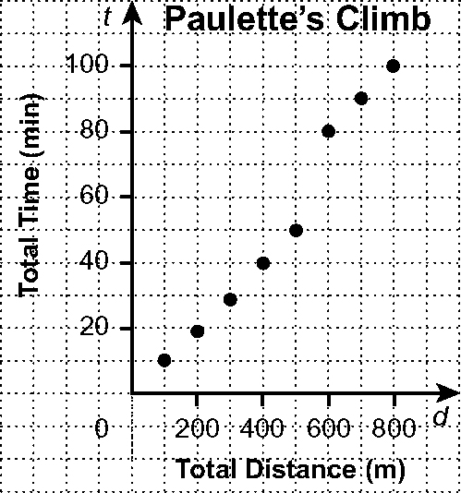
4.

5. Answers will vary. Example: The points lie along a straight line. As the distance increases, the time increases.

BLM 9−2 Chapter 9 Get Ready
1. Descriptions will vary.
a) The pattern can be described as letters of the alphabet beginning with b, and skipping two letters each time.
b) The pattern can be described as letters of the alphabet beginning with p and going backwards by two letters each time.
c) The pattern can be described as multiples of 5 beginning with 15.
d) The pattern can be described as integers beginning with 9 and decreasing by 5 each time.

2. Descriptions will vary.
a)
Figure Number | 1 | 2 | 3
Number of Squares | 4 | 7 | 10
The number of squares begins with 4 and increases by 3 with each new figure.
b)
Figure | 1 | 2 | 3
Number of Cubes | 4 | 6 | 8
The number of cubes begins with 4 and increases by 2 with each new figure.
3. Variables may differ.
a) 5p, where p represents the number of pencils in each box
b) 12d ÷ 4, or 3d, where d represents the number of DVDs in each carton
c) c− 7, where c represents the original number of candies in the bag
4. a) (−2, −3)
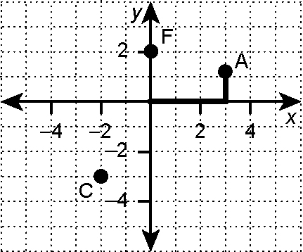
b)

Point F is located 2 units above the origin on the y-axis.
5. C(−1, 0), G(2, −1), D(3, 2)
6. | Point | A | B | E
 | x | −1 | 0 | 3
 | Y | 2 | 1 | 1

BLM 9−3 Chapter 9 Warm-Up
Section 9.1
1. Estimates will vary, depending on the methods used. Examples:
a) Estimate: −1000; Calculate: −1040
b) Estimate: −10; Calculate: −10.6
2. a) +1 b) +104 3. −4.2 students 4. −16
5. a) The bar graph. Explanations will vary. Example: You can determine the number of books in each category and then add them. The circle graph gives you percentages instead of numbers.
b) The circle graph. Explanations will vary. Example: You can use the percentages on the circle graph to calculate what proportion of $100 to spend on each type of book. Using the bar graph would take more calculations.

6. = 20 7. = 0.575 or 0.58
8. 3 : 2 9. 0 : 5 10. 3 : 7
Section 9.2
1. Answers will vary. Examples:
• The graph provides data on the cost of muffins. One muffin costs $0.75, two muffins cost $1.50, three muffins cost $2.25, ...
• The points appear to lie along a straight line.
• To move from one point to the next, you move one unit horizontally and 1.5 units vertically.
2.
Number of Muffins, m | 1 | 2 | 3 | 4 | 5
Total Cost, C ($) | 0.75 | 1.50 | 2.25 | 3.00 | 3.75
3. $6.00
4. No. You cannot buy part of a muffin.
5. 9.5² = 5.5² + b²
90.25 = 30.25 + b²
60 = b²
7.75 ≈ b
The length of the unknown side is 7.75 m.
6. a) 25 b) 225 c) 625
7. a) 7 b) 11 c) 100
8. Answers may vary. Examples:
a) 10² = 100 b) 8² = 64
11² = 121 9² = 81
≈ 10.4 ≈ 8.7
9. end of first month = 200 + 100 = 300
end of second month = 300 + 150 = 450
10. a) 1.2, 120% b) 1.15, 115%
Section 9.3
1. Table 1: Consecutive values of s differ by 1. Table 2: Consecutive values of a differ by 1. The consecutive values of the first variables differ by the same amount within each table.
2. Table 1: Values of t differ by 2, 3, and 4. The difference is not the same. Table 2: Values of b differ by 4. The difference is the same.
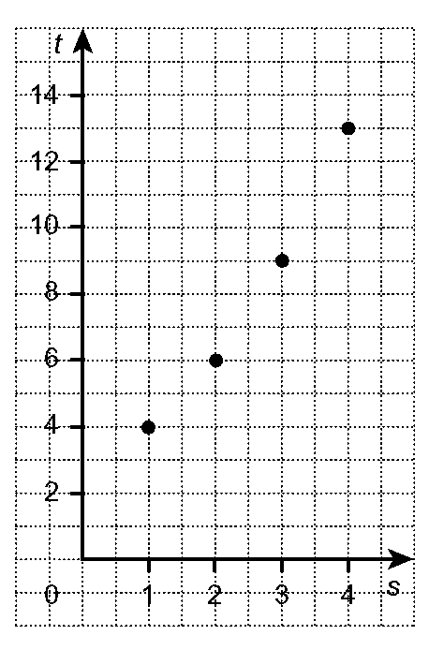
3. Table 1:

The relationship is not linear.
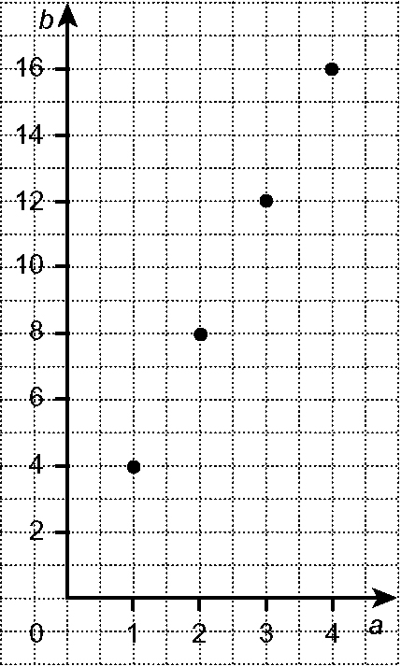
Table 2:

The relationship is linear.
4. Table 1: The difference in values of t is not the same and the relation is not linear.
Table 2: The difference in values of b is the same and the relation is linear.
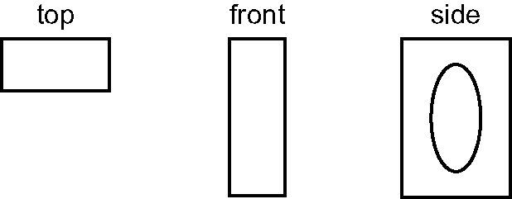
5.

6. surface area of
top and bottom ≈ (3 × 1²) × 2
≈ 6
surface area of side ≈ (3 × 2) × 5
≈ 30
The surface area is about 36 cm².
7. volume ≈ (3 × 1²) × 5
≈ 15
The volume is about 15 cm³.
8. surface area of
triangular ends ≈ (2 × 2 ÷ 2) × 2
≈ 4
surface area
of two sides ≈ 2 × 5 × 2
≈ 20
surface area of bottom ≈ 2 × 5
≈ 10
The surface area is about 30 m².
9. volume ≈ (2 × 2 ÷ 2) × 5
≈ 10
The volume is about 10 m³.
10. a) volume of a
rectangular prism ≈ 5 × 2 × 2
≈ 20
The volume is about 20 m³.
b) Answers will vary. Example: The values are the same, but for the volume of a triangular prism, you multiply the height of the triangle
(2.3 m), the base of the triangle (2 m), and the height of the triangular prism (4.5 m), and then divide by 2. You do not divide by 2 for the volume of a rectangular prism.

BLM 9−4 Chapter 9 Problems of the Week
1. y = 3x + 1 2. Answers will vary.
3. Answers will vary but should include drawing a coordinate grid, making a table of values, and plotting the points.
4. 5 = 4(3) + b
5 = 12 + b
5 − 12 = 12 − 12 + b
−7 = b
5.
x | y = x − 4 |  | x | y = 3x − 6
−2 | −6 |  | −2 | −12
−1 | −5 |  | −1 | −9
0 | −4 |  | 0 | −6
1 | −3 |  | 1 | −3
2 | −2 |  | 2 | 0
3 | −1 |  | 3 | 3
4 | 0 |  | 4 | 6
5 | 1 |  | 5 | 9

a) Yes. In y = x − 4, y is obtained by subtracting 4 from x, so the numbers continue to get smaller. In y = 3x − 6, y is obtained by multiplying x by
3 and then subtracting 6, so if x is a negative value, it decreases in value when multiplied by
3 and then decreases even further when 6 is subtracted from it.
b) Yes. In y = x − 4, each increasing value of y is obtained by subtracting 4 from a larger number, resulting in a larger difference. In y = 3x − 6, each value of y is obtained by multiplying 3 by a larger number, resulting in a larger product.
c) When x = 1, the value of y in both equations is −3.
d) Answers may vary. Example: The equations both have a point at (1, −3) because, for both equations, the value of y is equal to − 3 when x = 1.
6. a) Answers may vary.
b) Common points are shared by none of the fractions.
c) For , an algebraic expression is
2x = y; for , it is 3x = y; for ,
it is 4x = y; and for , it is 5x = y.
d) If you can find the numerator and denominator of a fraction along a line of points on the graph, the fraction has an equivalent fraction in lowest terms along that line. For example, you can find the point (4, 16) along the set of points for, so can be expressed in lowest terms as .

BLM 9−5 Section 9.1 Extra Practice
1. a)
Radius of a Circle (cm) | 1 | 2 | 3 | 4 | 5
Diameter of a Circle (cm) | 2 | 4 | 6 | 8 | 10
b) 16 cm c) 11 cm d) Yes. It is possible to have a radius that is 4.5 cm.
2. Graph B
3. a)
Number of Posters, n | 1 | 2 | 3 | 4
Cost, C ($) | 8 | 16 | 24 | 32
b) 6 x 8 = $48
c) No. You cannot buy part of a poster.

BLM 9−6 Section 9.1 Math Link
1. Answers will vary. Example: The cost steadily increases from day 1 to day 7. The points lie along a straight line.
2., 3. b)., 4.
Number of Days, d | Cost,  C ($) | Cost of Deluxe  Tour ($)
1 | 400 | 400 + 300 = 700
2 | 800 | 800 + 300 = 1100
3 | 1200 | 1200 + 300 = 1500
4 | 1600 | 1600 + 300 = 1900
5 | 2000 | 2000 + 300 = 2300
6 | 2400 | 2400 + 300 = 2700
7 | 2800 | 2800 + 300 = 3100
8 | 3200 | 3200 + 300 = 3500

3. a) $3200
5. Answers will vary. Example: Both costs increase by $400 per day.
6. Answers will vary. Example: The deluxe tour costs $300 more per day than the regular tour.

BLM 9−7 Section 9.2 Extra Practice
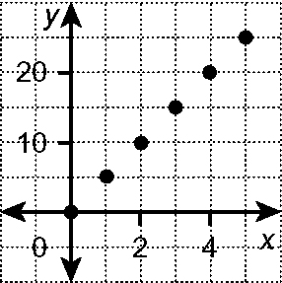
1. a)

b) The difference in x-values is 1. The difference in y-values is 5. c) 5x
2. a) The relationship is not linear. Consecutive values of s always increase by 1, but consecutive values of t do not always increase by the same amount.
b) The relationship is linear. Consecutive values of h always decrease by 3, and consecutive values of I always increase by 3.
3. 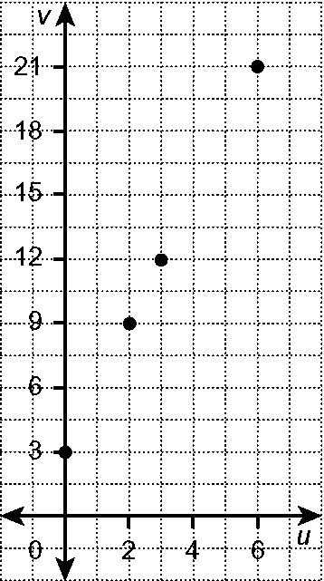
Yes. The points appear to lie along a straight line.
4. a)
Number of $10 Bills | 5 | 6 | 7 | 8 | 9
Number of $5 Bills | 10 | 8 | 6 | 4 | 2
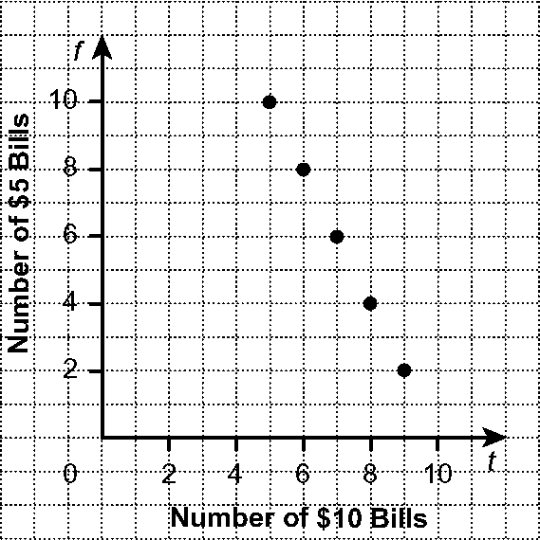
b)

Yes. The points appear to lie along a straight line.
c) No. Nineteen $5 bills results in $95, and
$95 + $10 ≠ $100.

BLM 9−8 Section 9.2 Math Link
1.
Number of Days,  d | Cost, C ($) | Ordered  Pair
1 | 36 + 40 × 1 = 76 | (1, 76)
2 | 36 + 40 × 2 = 116 | (2, 116)
3 | 36 + 40 × 3 = 156 | (3, 156)
4 | 36 + 40 × 4 = 196 | (4, 196)
5 | 36 + 40 × 5 = 236 | (5, 236)
6 | 36 + 40 × 6 = 276 | (6, 276)
7 | 36 + 40 × 7 = 316 | (7, 316)

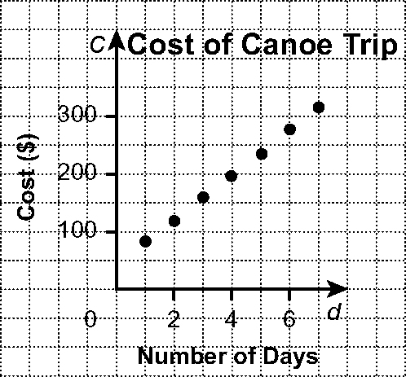
2.

3. Yes. Answers will vary. Example: The points lie along a straight line. Consecutive values of d always differ by 1, and consecutive values of C always differ by 40.
4. 36 + 40d 5. Answers will vary.

BLM 9−9 Section 9.3 Extra Practice

1. a) | x | −2 | −1 | 0 | 1 | 2
 | y | −7 | −4 | −1 | 2 | 5
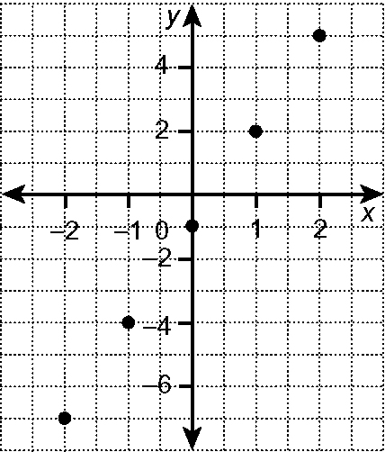
b)

c) 3(4) − 1 = y
12 − 1 = y
11 = y
d) −10 = 3x − 1
−9 = 3x
−3 = x

2. a) y = 0.5 b) = y, −8 = y c) x = −7
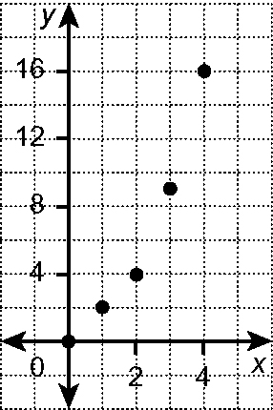
3. a)

b) No. 1. The points do not lie along a straight line. 2. The difference between consecutive values of x are the same but the difference between consecutive values of y are not the same.

BLM 9−10 Chapter 9 Test
1. B 2. C 3. A 4. D 5. D
6. a) b)
y = x − 4 |  |  | y = x + 5
X | y |  | x | y
0 | −4 |  | −3 | 2
1 | −3 |  | −1 | 4
2 | −2 |  | 0 | 5
3 | −1 |  | 1 | 6
4 | 0 |  | 3 | 8

c) d)
y = 2x |  |  | y = 3x
x | y |  | x | y
0 | 0 |  | −3 | −6
1 | 2 |  | −1 | −3
2 | 4 |  | 0 | 0
4 | 8 |  | 1 | 3
8 | 16 |  | 2 | 6

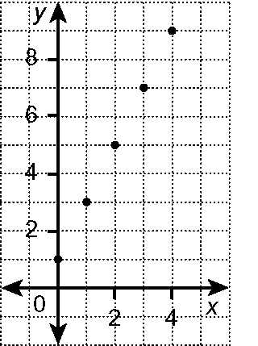
7. a)

b) Yes. 1. The points appear to lie along a straight line. 2. The difference between consecutive values of x is always 1, and the difference between consecutive values of y is always 3.

8. a) | Time, t (s) | Speed, s (km/h)
 | 0 | 0
 | 5 | 10
 | 10 | 25
 | 15 | 30
 | 20 | 35

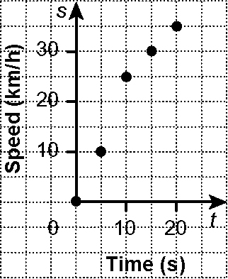
b)

c) No. Answers may vary. Examples:
• The points do not lie along a straight line.
• Consecutive values of t always have a difference of 5, but consecutive values of s do not always have the same difference.
d) Answers may vary. Examples:
• Consecutive values of s must differ by the same amount.
• Tina’s speed must increase at a constant rate.

BLM 9−11 Chapter 9 Wrap It Up!
1.−6. Answers will vary.

