Chapter 1 Self-Assessment
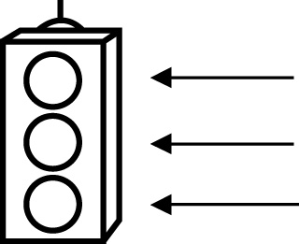 | RED I have not started moving in this area.  YELLOW I am moving along with caution in this area.  GREEN I am moving along confidently in this area.

BEFORE | DURING  (What I can do if I mark yellow or red.) | AFTER  (Proof that I can do this.)
1.1

I can compare information from different graphs.
I can identify the advantages of different types of
graphs.
I can identify the disadvantages of different types of
graphs.
1.2
I can explain how the size of the intervals on a graph
could be misleading.
I can explain how the visual representation of a
graph could
misrepresent data.
I can explain how the size of bars on a graph could be
misleading.
I can identify conclusions that do not agree with a
given data set or
graph.
I can explain the misrepresentation.
1.3
I can explain how a graph is used to
represent the data
from a given
situation.

