Chapter 2 Self-Assessment
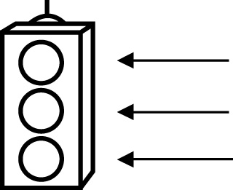 | RED I have not started moving in this area.  YELLOW I am moving along with caution in this area.  GREEN I am moving along confidently in this area.

BEFORE | DURING  (What I can do if I mark yellow or red.) | AFTER  (Proof that I can do this.)
2.1

I can represent two-term ratios.
I can represent three-term ratios.
I can identify ratios from real-life examples.
I can describe ratios from real-life examples.
I can record ratios from real-life examples.
I can represent a ratio as a fraction.
I can represent a ratio as a percent.
I can solve problems using ratios.

2.2
I can express rates using words.
I can express rates using symbols.
I can identify rates from real-life examples.
I can describe rates from real-life examples.
I can record rates from real-life examples.
I can solve problems using rates.
2.3
I can solve problems using proportional reasoning.
I can use more than one method to solve proportional
reasoning problems.

