Chapter 3 Self-Assessment
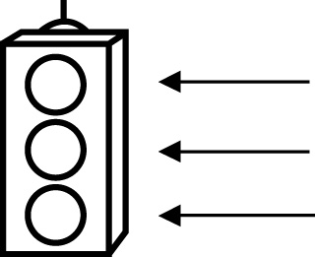 | RED I have not started moving in this area.  YELLOW I am moving along with caution in this area.  GREEN I am moving along confidently in this area.

BEFORE | DURING  (What I can do if I mark yellow or red.) | AFTER  (Proof that I can do this.)
3.1

I can identify a perfect square using square tiles.
I can identify a perfect square using prime factorization.
I can determine the square of a whole number.
I can determine the factors of a perfect square.
I can determine the square root of a perfect square.
3.2
I can model the Pythagorean relationship.
I can describe how the Pythagorean relationship applies
to right triangles.
I can determine whether or not a triangle is a right
triangle.
3.3
I can estimate the square root of a number that is not a
perfect square.
I can identify a number with a square root that is
between two given
numbers.
I can explain that a square root on a calculator may be an
approximation.
3.4
I can use the Pythagorean relationship to
determine the
missing side length
of a right triangle.
3.5
I can apply the Pythagorean relationship to solve
problems.
I can use the Pythagorean relationship to
determine distances
between objects.
I can verify that a triangle is a right triangle.

