Chapter 5 Self-Assessment
BEFORE | DURING  (What I can do if I mark yellow or red.) | AFTER  (Proof that I can do this.)
5.1
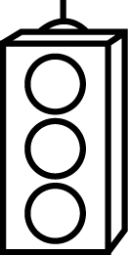
I can draw and label top, front, and side views of 3-D
objects.
I can build 3-D objects when given top, front, and side
views.
5.2
I can determine the correct nets for 3-D objects.
I can build 3-D objects from nets.
I can draw nets for 3-D objects.
5.3
I can link area to surface area.
I can find the surface area of a right prism.
5.4
I can find the surface area of a cylinder.

