Chapter 6 Self-Assessment
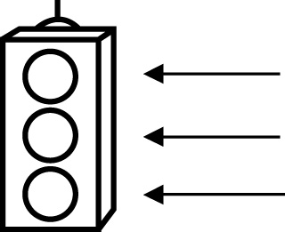 | RED I have not started moving in this area.  YELLOW I am moving along with caution in this area.  GREEN I am moving along confidently in this area.

BEFORE | DURING  (What I can do if I mark yellow or red.) | AFTER  (Proof that I can do this.)
6.1

I can multiply a fraction and a whole number.
I can solve problems involving the multiplication of a
fraction and a whole
number.
6.2
I can divide a fraction by a whole number.
I can solve problems involving the division of fractions
by whole numbers.
6.3
I can multiply two proper fractions.
I can solve problems involving the multiplication of two
proper fractions.

6.4
I can multiply two improper fractions.
I can multiply mixed numbers.
I can solve problems involving the multiplication of
improper fractions.
I can solve problems involving the multiplication of
mixed numbers.
6.5
I can divide two fractions.
I can divide mixed numbers.
I can solve problems involving the division of fractions.
I can solve problems involving the division of mixed
numbers.
6.6
I can decide when to multiply and divide fractions in solving problems.
I can apply the order of operations to solve problems
involving fractions.

