Chapter 7 Self-Assessment
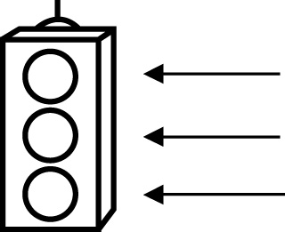 | RED I have not started moving in this area.  YELLOW I am moving along with caution in this area.  GREEN I am moving along confidently in this area.

BEFORE | DURING  (What I can do if I mark yellow or red.) | AFTER  (Proof that I can do this.)
7.1
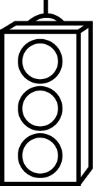
I can explain the meaning of volume.
I can determine the volume of a right rectangular prism.
I can determine the volume of a right triangular prism.
I can determine the volume of a right cylinder.
I can show that orientation does not affect volume.
7.2
I can use a formula to determine the volume of a right
rectangular prism.
I can use a formula to determine the volume of a right
triangular prism.

7.3
I can use a formula to determine the volume of a
cylinder.
7.4
I can solve problems involving right rectangular prisms.
I can solve problems involving right triangular prisms.
I can solve problems involving right cylinders.

