Chapter 9 Self-Assessment
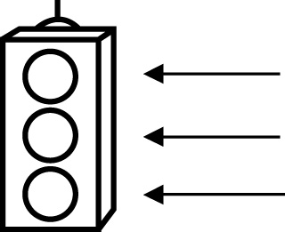 | RED I have not started moving in this area.  YELLOW I am moving along with caution in this area.  GREEN I am moving along confidently in this area.

BEFORE | DURING  (What I can do if I mark yellow or red.) | AFTER  (Proof that I can do this.)
9.1

I can describe patterns on the graph of a linear
equation.
I can create a table of values using the points on a graph.
I can determine the missing value in an ordered pair for a
linear equation.
9.2
I can describe the relationship between the variables of a
graph.
I can decide if a table of values represents a linear
relation.
I can graph points from a table of values.

9.3
I can create a table of values by substituting into a
linear equation.
I can construct a graph from a linear equation using
integers.
I can determine the missing value in an ordered pair for a
given equation.

