Chapter 10 Self-Assessment
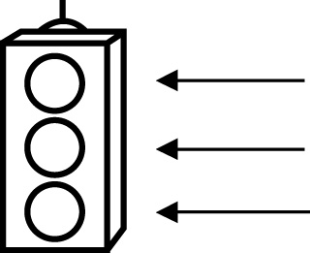 | RED I have not started moving in this area.  YELLOW I am moving along with caution in this area.  GREEN I am moving along confidently in this area.

BEFORE | DURING  (What I can do if I mark yellow or red.) | AFTER  (Proof that I can do this.)
10.1

I can model a problem with a one-step linear equation
of the form ax = b,
.
I can solve a one-step linear equation and record the
process.
I can verify the solution to a one-step linear equation.
I can correct an error in a solution to a one-step linear
equation.

10.2
I can model a problem with a two-step linear equation
of the form
ax + b = c.
I can solve a two-step linear equation and record the
process.
I can verify the solution to a two-step linear equation.
I can draw a diagram to solve a linear equation.
10.3
I can model a problem with a two-step linear equation
of the form .
I can solve a two-step linear equation and record the
process.
I can verify the solution to a two-step linear equation.
I can correct an error in a solution to a two-step linear
equation.

10.4
I can model a problem with a two-step linear equation
of the form a(x + b).
I can solve a two-step linear equation and record the
process.
I can verify the solution to a two-step linear equation.
I can apply the distributive property to solve a linear
equation.
I can correct an error in a solution to a two-step linear
equation.

