Chapter 11 Self-Assessment
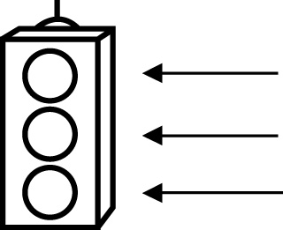 | RED I have not started moving in this area.  YELLOW I am moving along with caution in this area.  GREEN I am moving along confidently in this area.

BEFORE | DURING  (What I can do if I mark yellow or red.) | AFTER  (Proof that I can do this.)
11.1

I can determine the sample space of a probability
experiment with two
independent events.
I can represent the sample space in the form of a tree
diagram.
I can represent the sample space in the form of a table.
I can express the probability of an event as a fraction.
I can express the probability of an event as a decimal.
I can express the probability of an event as a percent.

11.2
I can determine the outcomes of two or more independent
events.
I can verify the total number of possible outcomes using a
different strategy.
11.3
I can solve probability problems.
I can verify their answers using a different method.

