Chapter 12 Self-Assessment
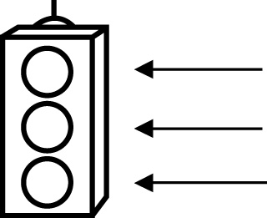 | RED I have not started moving in this area.  YELLOW I am moving along with caution in this area.  GREEN I am moving along confidently in this area.

BEFORE | DURING  (What I can do if I mark yellow or red.) | AFTER  (Proof that I can do this.)
12.1
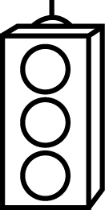
I can identify regular polygons that can be used to
create tessellations.
I can identify irregular polygons that can be used to
create tessellations.
I can describe why certain regular polygons can be
used to tessellate
the plane.
I can describe why certain irregular polygons can be
used to tessellate
the plane.
I can create simple tessellating patterns using polygons.

12.2
I can identify how translations can be used to create a
tessellation.
I can identify how reflections can be used to create a
tessellation.
I can create tessellating patterns using two or more
polygons.
12.3
I can identify how rotations can be used to create a
tessellation.
I can create tessellating patterns using two or more
polygons.
12.4
I can create tessellations from combinations of
regular and irregular
polygons.
I can describe the tessellations in terms of the
transformation used
to create them.

