Working with Circles

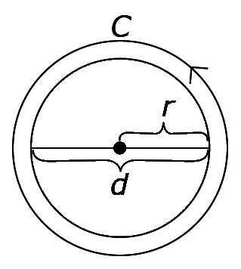
The diameter is the distance across a circle through
its centre. The diameter of a circle is twice the length
of the circle's radius. The circumference is the distance
around a circle.
d = 2r or , where r = radius and d = diameter
C = πd or C = 2πr, where C = circumference, r = radius, and d = diameter of a circle.
The radius of a circle is 2.4 cm.
The diameter is d = 2r. The circumference is C = πd.
2(2.4) = 4.8 = π (4.8)
The value of π is approximately 3.14. You can estimate the circumference to be about three times the length of the diameter
The diameter is 4.8 cm. ≈ 3.14(4.8)
≈ 15.07

The circumference is about 15.07 cm.

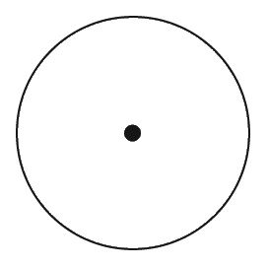

1. Measure the diameter of each circle.
a) b)

2. a) Estimate the circumference of each circle in #1.
b) Calculate the length of the circumference for each circle in #1. Use 3.14 as an approximate value for π.

Working with Angles

You can estimate the size of an angle in relation to 90° or a quarter turn.
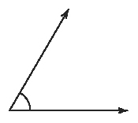

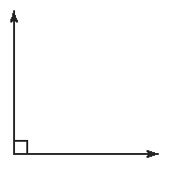
The angle is less than 90°. You could refine your estimate by
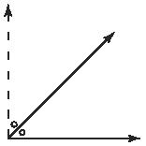
considering its size compared to or 90° and or 45°. You might conclude that the angle is between 45° and 90°, but closer to 45°. The actual measure of the angle is 60°.

3. Estimate the size of each angle.

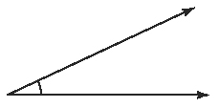
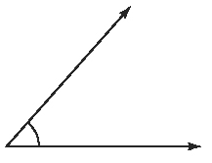
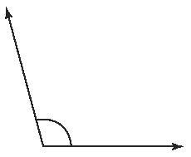
a) b) c)

4. Measure each angle in #3.

5. Sketch an angle that you estimate has a measure of 55°. Then, use a protractor to draw an angle that measures 55°. How close was your estimate to the actual angle measure?
6. Draw an angle that measures 150°.

Bisecting Angles

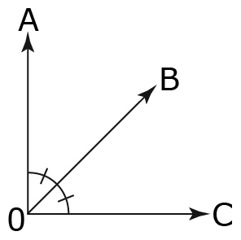
An angle bisector divides an angle into two equal parts.
OB bisects ∠AOC making ∠AOB = ∠BOC.
You can bisect an angle by:
• using paper folding
• using a ruler and a protractor

7. Bisect each angle.
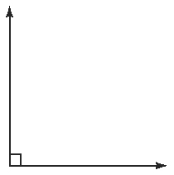
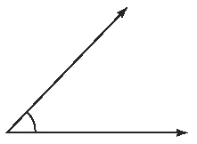
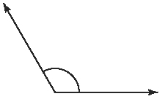
a) b) c)

8. Draw ∠ABC = 70°. Then, draw the angle bisector and label it BX. What is the measure of ∠ABX? How do you know?

Perpendicular Bisectors
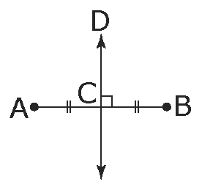
A perpendicular bisector is a line that divides a line
segment in half and is at right angles (90°) to the line
segment. DC is the perpendicular bisector of AB.
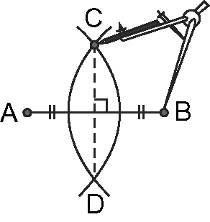
You can make a perpendicular bisector using:
• paper folding
• a ruler and a right triangle

9. Draw the perpendicular bisector for each line segment.

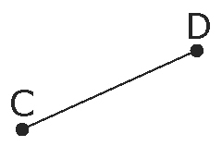
a) b)
10. Draw the perpendicular bisector for diameter AB. What information do you know for sure about AB or its perpendicular bisector?
