Section 10.1 Extra Practice
1. Determine the measure of ∠ABC and ∠AEC. Explain how you determined your answers.
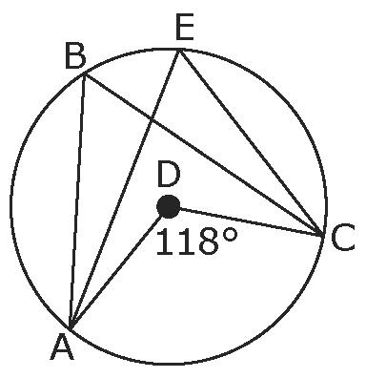
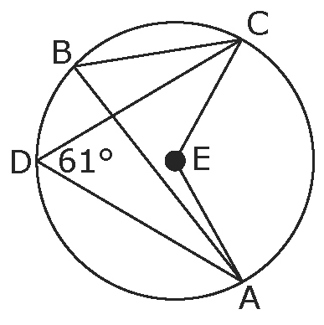
a) b)

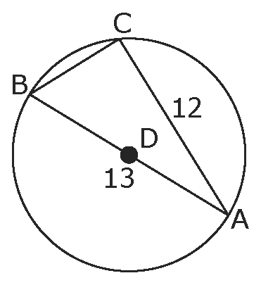
2. Determine the length of chord BC in each of the following.
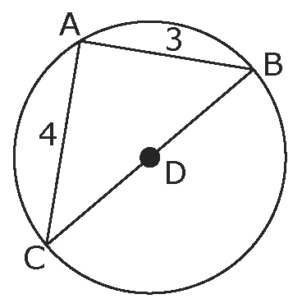
a) b)

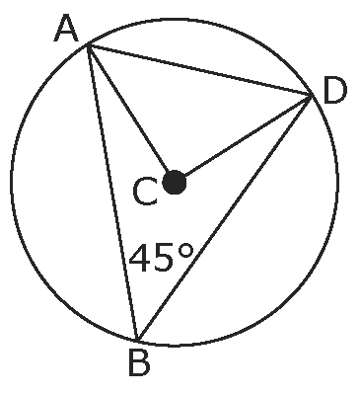
3. Point C is the centre of a circular flower bed
with a radius of 8 m. The flower bed is divided
as shown in the diagram. If ∠ABD = 45°, determine
the length of AD to the nearest tenth of a metre.

4. Find the unknown angle measure in each of the following diagrams.
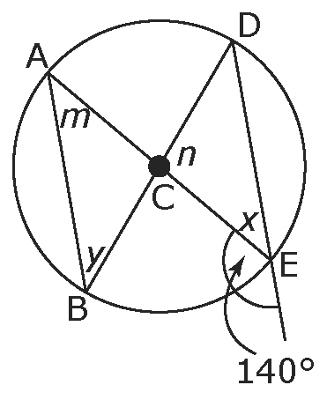
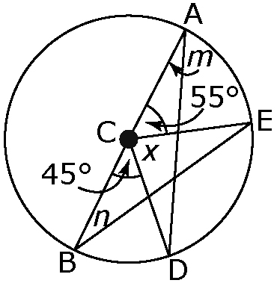
a) b)

∠m =

∠n =

∠x =

∠y =
∠m =

∠n =

∠x =

