Section 10.2 Extra Practice
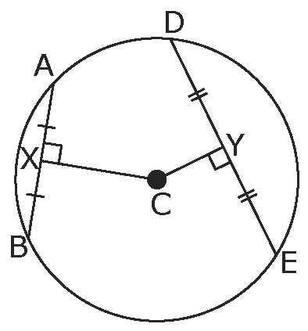
1. Describe the conclusion(s) that can be drawn
from the diagram.

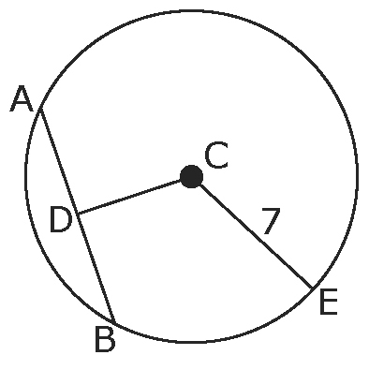
2. In the diagram, D is the midpoint of AB. AB is 8 units in
length. Find the length of CD to the nearest tenth.
Justify your answer.

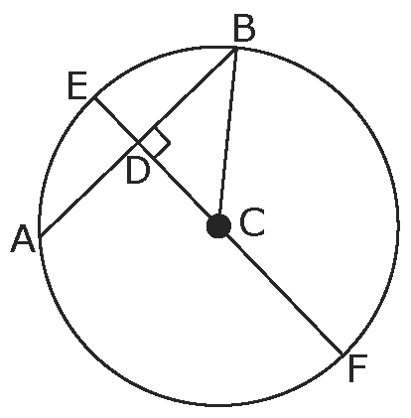
3. In the diagram, AB = 8 units and CD = 5 units. Find
the lengths of CB, ED, and EF to the nearest tenth.

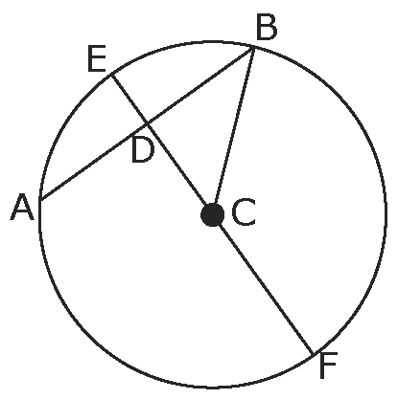
4. In the diagram, diameter EF bisects chord AB at D. If
EF = 24 units and AB = 16 units, find the lengths of
CF, CB, BD, CD, and DE to the nearest tenth.

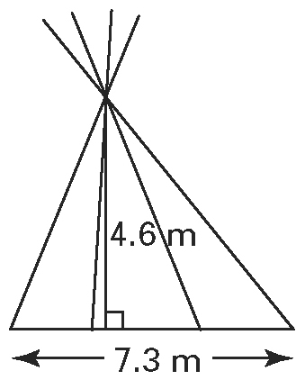
5. The North American Plains Indians constructed tipis that were
7.3 m in diameter and stood 4.6 m tall. The tipi was a tilted cone
with the door facing the sun, and the back was steeper than the
front to add strength against the wind. A person standing 1.2 m
from the centre of the ring would be directly below the vent at
the top of the tipi.
a) What is the width of the tipi ring directly below the vent?
b) What is the minimum length, to the nearest tenth of a metre, of a pole erected at that point through the vent if the pole extends 0.9 m above the tent?

Show a floor diagram to support each of your answers.

