Section 10.2 Math Link
This worksheet will help you with the Math Link on page 393.

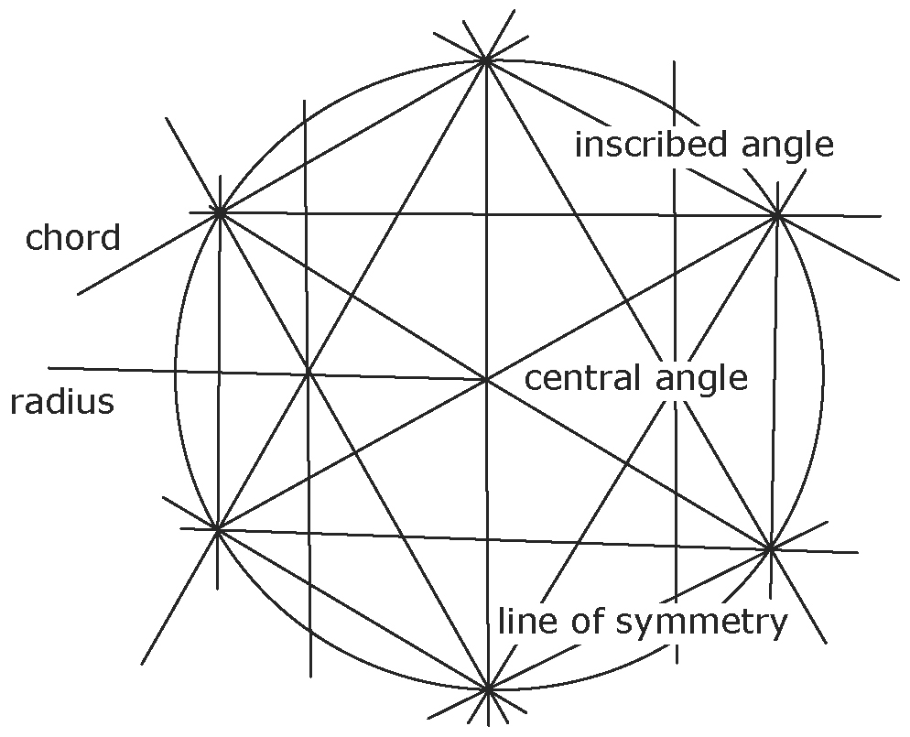
1. On the diagram, use coloured pencils to
highlight an example for each label. Use
an arrow to point from each label to the
corresponding example.
2. a) Refer to the portion of the sand mandala
shown in the picture on page 393. Use it
as an example when designing your
own mandala.
b) Draw a circle about 20 cm in diameter
on a piece of paper. Outline the border
so that you can measure directly from it.
c) Find and clearly mark the exact centre of
your mandala. The mandala you build will
include chords, radii, inscribed angles, and central angles.
d) Measure a distance from the outside edge of your circle along one radius.
e) Draw a chord that bisects this radius at the point you chose. Repeat this process along other evenly spaced radii, making line segments that are chords crossing the arc of the circle of your mandala.
f) Mark the intersection points where the chords meet the arc of the circle.
g) Create inscribed angles using these points.
h) Draw new chords that are perpendicular to your radii and parallel to your original chords. See the example you drew in the diagram above.

3. If you want to display your mandala, you need to know how much room it will take up.
a) What is the diameter of your mandala?
b) The formula for the circumference, C, of a circle is C = πd. What is an approximate whole number value for π?
c) What is a reasonable estimate for the circumference of your mandala? Explain your answer.

4. Symmetry means that both sides of a figure look the same. A line of symmetry has an exact reflection of the same figure on each side of the line. How do you think Buddhist monks ensure symmetry in their mandalas?

