Section 10.3 Math Link
This worksheet will help you with the Math Link on page 403.

1. a) Design a piece of art or a company logo using at least one circle. You can use your own name or initials if you like.
b) On grid paper, draw a box that is at least 22 cm on two sides. Your box might be a rectangle or a square. This is the space in which your logo will fit.
c) Create a circle on your grid paper, about 15 cm to 22 cm in diameter. Mark the centre point. Do not let your circle touch the box.
d) Create an original design for your logo or artwork using inscribed angles, central angles, chords, and at least one tangent.
Example:

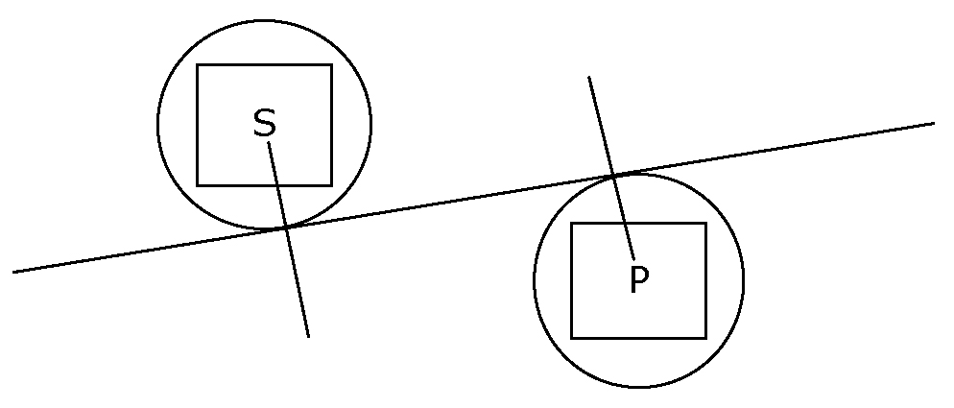

2. Determine and record the measures of any chords, radii, diameters, or tangent lines in your design.
Example: In the diagram above, circles S and P are tangent to each other.
The line segment that is tangent to circle S at 90° to the radius is tangent to circle P at 90° to its radius.

