Chapter 10 Test
For #1 to 4, select the correct answer.

1. The perpendicular from the centre of a circle to a chord ______________ the chord.
A bisects B intersects C is tangent to D passes through

2. Which of the following describes an inscribed angle in a circle?
A segments that have both endpoints on the circumference of a circle
B the angle formed by two chords that share a common endpoint on the circumference of a circle
C an angle formed by two radii of a circle where the endpoints are on the circle
D an angle where the vertex is inside the circle at the intersection of two chords

3. The measure of the central angle of a circle is ____________ the measure of an inscribed angle subtended by the same arc in the circle.
A twice B half C equal to D supplementary to

4. Which of the following describes a tangent to a circle?
A a line that intersects the circle at two points
B a chord that intersects the circle at two points
C a line that intersects the circle at only one point
D a chord that intersects the circle at only one point

Use the following diagram to complete the statements in #5 and 6.

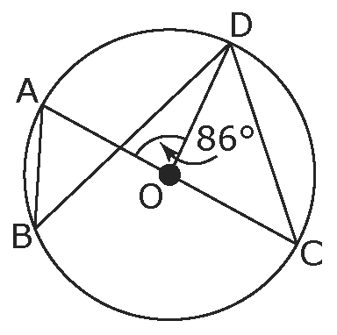

5. If the measure of ∠AOD is 86°, then the measure of ∠AOD is ____.
6. The measure of ∠ABD is ____.

Short Answer

7. What is the measure of ∠ACB?

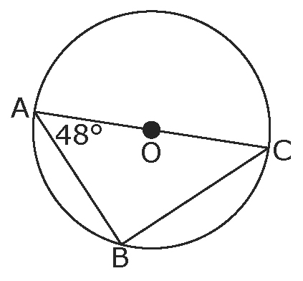

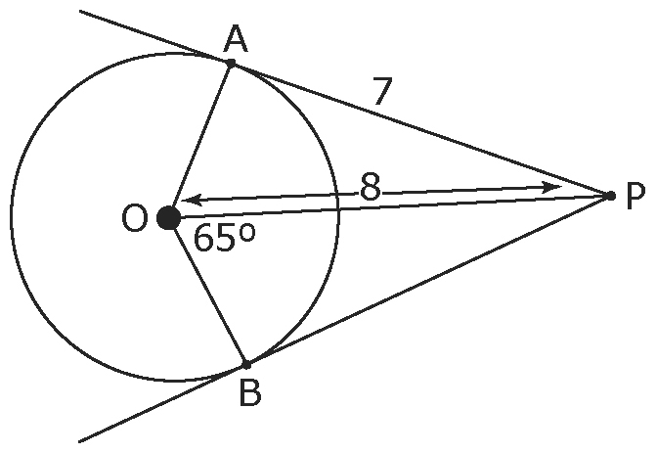
8. The centre of the circle is O. Points A and B
are tangent to the circle.
a) What is the measure of ∠PAO?
b) What is the length of ?
c) What is the measure of ∠BPO?

Extended Response

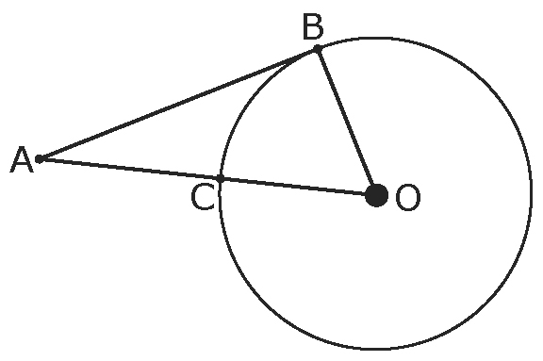
9. In the diagram, is tangent to the circle.
The length of is 24 cm and
the length of is 10 cm.
a) What is the length of ?
b) What is the length of ?
10. A subway track must pass through a cylindrical tunnel. The tunnel is 6 m in diameter. How wide should the track bed be so that the maximum height at the centre of the tracks is 4.5 m? Express your answer to the nearest tenth of a metre.
