Making a Dream Catcher
Before you begin, you will need:
• 12.5-cm metal ring
• small beads
• thin strips of leather or suede lace (approximately three times the circumference of the ring)
• artificial sinew (about 2 m for a 12.5-cm ring)
• glue
• feathers
• bloodstone or special bead

1. Glue one end of the strip of leather to the metal ring. Wrap the leather around the ring until the ring is completely covered. Cut and glue the end piece to the ring.
2. Mark off eight points that are equidistant from each other on the circumference of the ring.
3. Cut a 2-m length of artificial sinew. Tie it to one of the marked points on the ring. Note: If the piece is not long enough to complete all rows of webbing, additional sinew can be added by knotting the ends together.
4. Make a half-hitch knot at the next marked point.
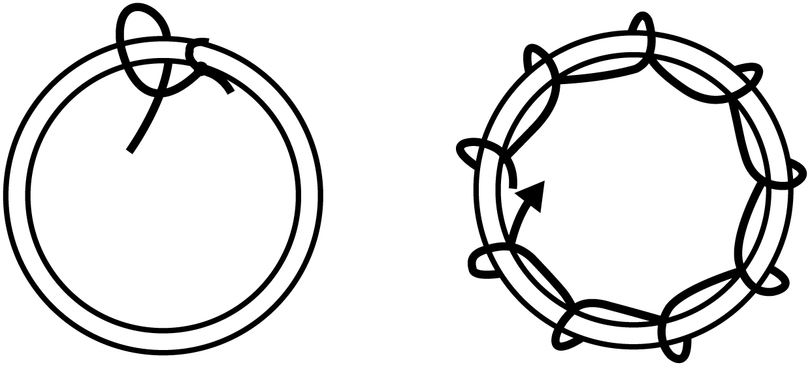
5. Continue making knots at the remaining marked points.

6. To start the second row, make a half-hitch knot in the centre of the first chord you made. Continue making knots at the centres of the remaining chords. See the following diagram. Small beads can be threaded on the sinew before or after the knots.
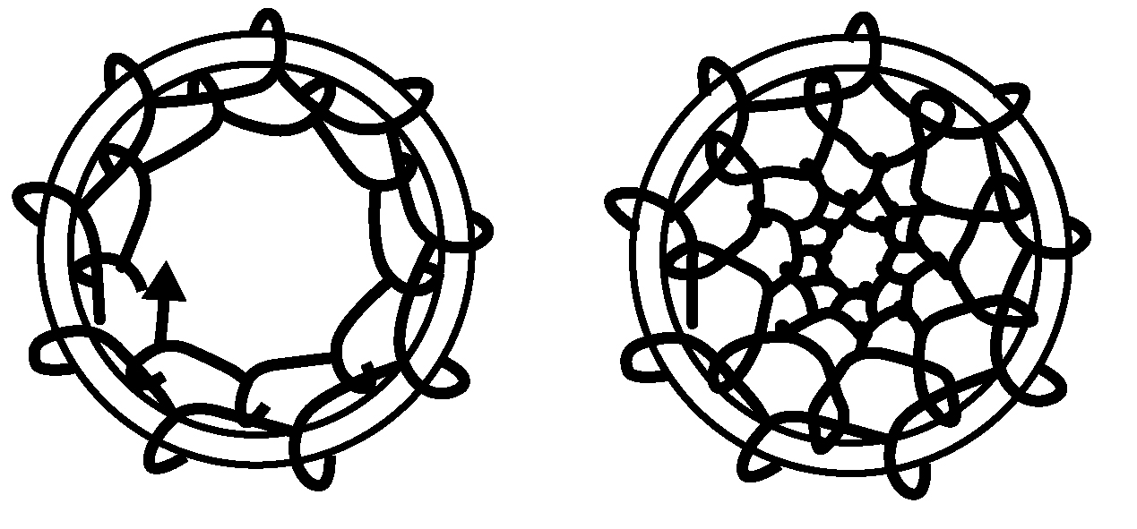
7. Continue knotting and beading until there is approximately a 5-cm diameter opening in the centre.
8. Tie a knot and attach a bloodstone or special bead to hang in the centre.
9. Cut three lengths of leather or suede to attach at three equally spaced points on the bottom third of the ring. Tie these strips with a double-hitch knot. Attach beads and feathers to hang down.
10. Attach a double hitch knot to the top for hanging.
