Chapter 11 Math Link Introduction
This worksheet will help you with the Math Link introduction on page 413.

Val decided to study the population of the ungulates in Elk Island National Park.
The table shows the data she collected from the park warden.

Ungulate | Approximate Total Park Count  (2007 Fall Count)
Plains bison | 425
Wood bison | 400
Elk | 605
Moose | 300
Deer | 558

1. a) Choose two types of graphs to display the data that Val collected.

For a bar graph or a line graph:  • Decide on a scale.  • Title and label both axes.  • Plot the categories along the x-axis.  • Plot the values along the y-axis.  • Add a title. | For a circle graph:  • Draw a circle using a compass.  • Use a protractor to measure and draw each angle.  • Label each sector with its category and its percent.  • Shade each sector.  • Add a title. | For a pictograph:  • Decide on symbols.  • Provide a key.  • Add a title.

If you choose a circle graph, complete the following table to calculate the central angles. The first one is done for you.

Ungulate | Total Park Count | Percent of Total | Decimal Value | Central  Angle
Plains bison | 425 | = 18.6% | 0.186 | 0.186 × 360° = 67°
Wood bison | 400
Elk | 605
Moose | 300
Deer | 558

b) Use grid paper to draw the graphs.

c) Explain why you chose each type of graph.
____________________________________________________________
____________________________________________________________

2. What is the most common ungulate in the park? Explain how you know.
_______________________________________________________________
_______________________________________________________________

3. Elk Island National Park has an area of 194 km².
a) About how many times greater is the number of elk than the area of the park? ____
b) What is the mean number of elk per square kilometre, to the nearest tenth?
Hint:

c) Compare your calculated answer in part b) to your estimate in part a). Is your answer reasonable? YES NO Explain.
____________________________________________________________

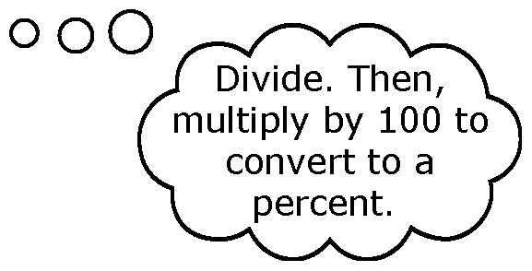
4. What percent of the ungulate population do bison represent?
Hint:

5. You will study an issue related to wildlife protection and management. As you do, you will develop your own research project. Your project will involve collecting, displaying, and analysing your data. You might study birth rates, death rates, or migration patterns of an animal population. Or, you might consider the effects of tourism, recreation, or environmental factors such as pollution, on a population.
a) You might study a wildlife issue in a park. If so, what park will you
choose? ____________________
b) Where is the park located? ____________________
c) What issue interests you? Search magazines or the Internet to research at least two areas of interest. List your areas of interest.
____________________ ____________________

