Chapter 11 BLM Answers

BLM 11–1 Chapter 11 Math Link Introduction
1. a), b) Examples:
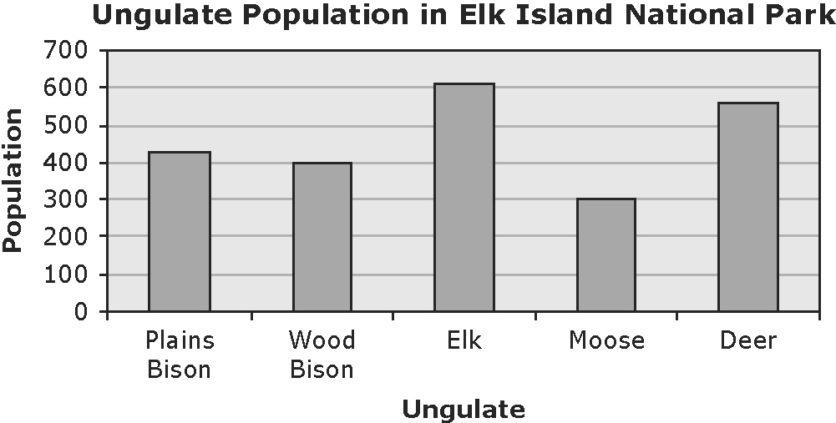

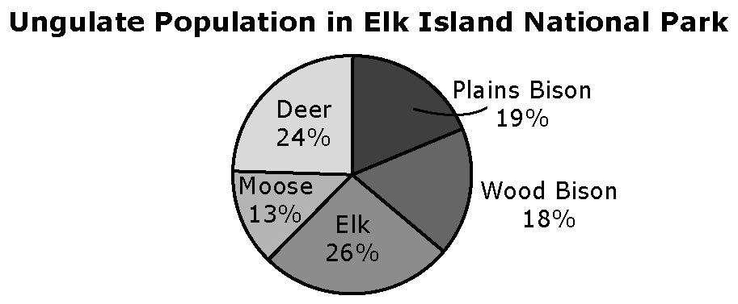
c) Example:
• The circle graph compares different ungulates to the whole ungulate population using percents.
• The bar graph compares the number of different ungulates in the park.
2. Example: The elk is the most common ungulate because it has the largest population.
3. a) Example: About three times
b) = 3.1. There are approximately 3.1 elk per square kilometre.
4. 36%
BLM 11–2 Chapter 11 Get Ready
1. a) Mean = 7.22; Median = 8; Mode = 8
b) Mean = 5.14; Median = 5; Mode = 4.3
2. Example: 2, 2, 6, 3, 7
3. Example using the data set 3, 5, 7, 3, 5, 2,
7, 3:
• The mean is easiest. You add the values and divide by the number of values. = 4.375
• The mode is next easiest. The value that occurs most often is 3.
• The median is the most difficult. The value halfway between the two middle numbers 3 and 5 (after they have been arranged in order) is 4.
4. a) 6 b) 24
5. Example: The highest value is 7 more than the lowest value, 10. The highest value is 17.
6. a) Tap A b) 15 L c) 40 – 10 = 30. The difference is 30 L.

7. a) 30% b) Example: About 43% c) Example: 5% + 22% = 27%; 0.27 × 500 = 135. I would expect 135 out of 500 boys to watch up to 2 h of TV per day.
BLM 11–3 Chapter 11 Warm-Up
Section 11.1
1. x = 100°; y = 80°
2. AC = 12 cm; AB = BC = 8.5 cm
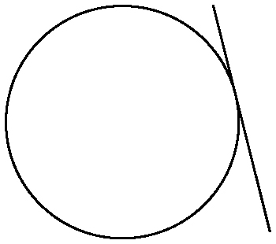
3. 35° 4. 11.5 m 5. Look for a line that touches the circle at one point but does not pass through the circle. Example:

6. Approximately 98 books
7. Adventure 8. 66.7%
9. No, the data provided does not indicate individual preferences.
10. Example: Yes, the Wong family may prefer other categories. The data collection method may not have allowed the Wongs to choose categories beyond the ones given.
Section 11.2
1. 128° 2. 39°
3. a) Bias, use of language, ethics, cost, time and timing, privacy, cultural sensitivity
b) Look for an example for any one factor. Example:
• cultural sensitivity: Surveying people about their favourite sausage. The question assumes that all people eat sausage, which is not true. For some people, this may be culturally sensitive.
4. Example: The question assumes that customers have a favourite dish. Perhaps, they did not like any dish.
5. Example: What is your favourite academic subject from the list? Circle your choice. (Provide a list of all the academic subjects.)
6. 1% 7. 10% 8. 300
9. A, C, E, G, I, K, M, O, Q, S, U, W, Y
10. B, D, F, H, J, L, N, P, R, T, V, X, Z
Section 11.3
1. Look for an opinion and a supporting point. Example: Halfway through the school year. Students may have forgotten the benefits of homework if they are surveyed during the summer or during exams.
2. Example: Are you in favour of doing homework on a daily basis? If you answered No, what reason best explains why? Circle one. (Provide list of reasons).

3. a) voluntary response sample; convenience sample b) Example: No, neither sample is random. The results will not likely represent the population.
4. a) systematic sample b) Example: Yes. Students may feel awkward about disclosing their voting preferences.
5. Example: Systematic sample: Choose every fourth student from an ordered list of all students.
6. a) 90 b) $10.01 7. 30%
8. 340 9. 6 10. 1425
Section 11.4
1. Example: Conducting a mail survey about hockey equipment during the summer when people are not playing hockey is costly for a company as people are less likely to respond.
2. Example: The sample could be random if the three names of colleges were randomly drawn from a list of all the names of Canadian colleges.
3. Example: Convenience sample since participants are easily accessible
4. Example: No, the data were collected from one high school. The local university likely draws students from more than one high school.
5. a) 20% b) Example: Each activity has an equal chance of being chosen.
c) Example: Experimental probability because it will give a more accurate reflection of students’ preferences
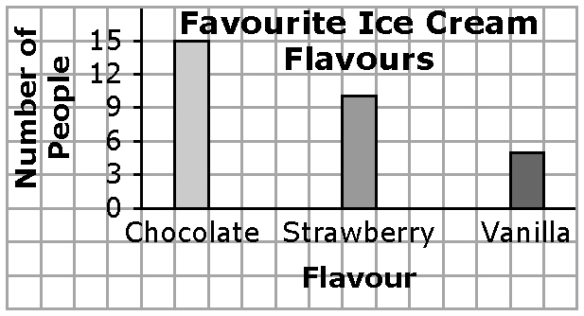
6. Example:

7. Example:
Flavour | Percent
Chocolate | 50%
Strawberry | 33%
Vanilla | 17%
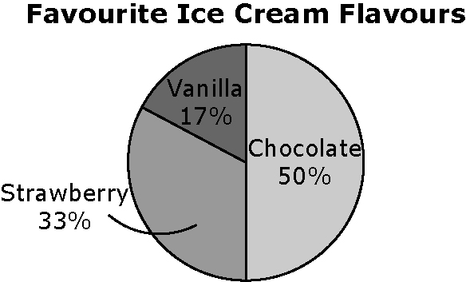
8. Example:

9. Example: No, line graphs are best for showing changes in data over time.
10. Example: Yes, people would not be limited to three flavours and be free to indicate their preference for a different flavour.

BLM 11–4 Chapter 11 Problems of the Week
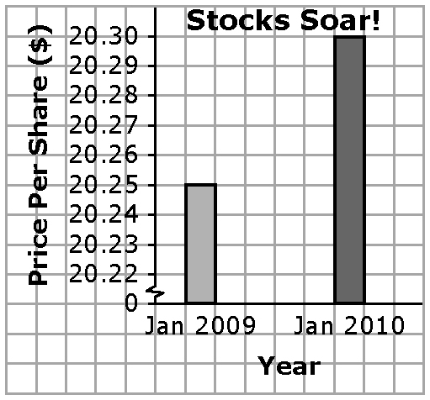
1. a)

b) The break in the scale creates the misleading impression that the stocks have increased significantly in value.
2. a) Example: This year an average of 6.4% of students were absent compared to last year when an average of 7% of students were absent. Although this is a slight improvement, it does not represent a significant change.
b) Examples:
• How many months does the 6.4% rate represent? If it is early in the school year, it would be premature to make a statement about improved attendance.
• What absentee rate would be considered a significant improvement?
• Is an absentee rate of 6 or 7% reasonable?
3. Example: The mean for each set of scores is 63%. For Amy, the median is between 90 and 45, and the mode is 90. For Peter, the median is between 65 and 61, and the mode is 65. For Molly, the median is between 73 and 63, and there are 2 modes (95 and 52). The mean is the most accurate reflection of performance.
4. a) Example:
Sample | Likely Bias | Reason
Sample Current customers | In favour | They are already happy with the product. It might be useful to know why they are happy.
Ex-customers | Not in favour | They are unhappy with the product. It might be useful to know why.
Daytime  phone | Non-working adults | Many people who are at home during the day do not work. Their opinions may not represent all working adults.
E-mail | Adults with Internet access | Internet users may not represent all working adults.
b) Examples:
• No. An online survey for Internet products can ignore people who do not use the Internet.
• No. A phone survey in the afternoon for a product aimed at retired adults will likely result in reaching the target population.
BLM 11–6 Section 11.1 Extra Practice
1. a) Example: Ethics: There is a lack of information. Does the company really intend to give away a trip? What are the eligibility requirements? How will the winner be selected? What are the chances of winning?
b) Example: Time and timing: The interest group is taking advantage of the recent vandalism at the high school to promote their agenda. The population might believe that teens were involved in the acts of vandalism and may more likely support a curfew.
c) Example: Bias: Many people attending a hockey game are more likely in favour of building a new arena.
d) Example: Privacy: The coach is violating the privacy rights of parents. The coach could have asked parents who are interested in driving to submit a confidential criminal record check.
e) Example: Language: The wording in the question may lead people to answer favourably.
f) Example: Cost: Sending the package and survey by mail is very costly. The money spent on promotion could be better directed to buying plants. Using a survey method that is more cost effective should be considered.
2. a) Example: Are you in favour of starting a community garden? YES NO If Yes, are you in favour of buying seeds and tools? YES NO
b) Example: Which Internet browser do you use most often? A Explorer B Firefox C Safari
D Other ______
c) Example: Will you consider hiring our landscape company? YES NO If Yes, what services do you need done? Circle each one that applies. (Provide a list of services.)
d) Example: We are planning to offer a free option in our new cell phone package. Which free option would you most prefer? A Message manager B Texting
BLM 11–8 Section 11.2 Extra Practice
1. a) Example: People who purchased the cell phone. Sample; It would be costly and time-consuming to survey all customers.
b) Example: All grade 9 students. Population; The group is easy to survey and the results would facilitate activity planning.
c) Example: All Arctic grayling in Lake Athabasca. Sample; It would be almost impossible to count the population, and it would be costly and time-consuming.
d) Example: All members of the Hunters and Trappers Association. Sample; It may be difficult to reach all members.
e) Example: All people who rent the arena. Population; The population is small and easy to survey.
f) Example: All grade 9 students. Population; The population is easy to survey.
g) Example: All residents in the new subdivision. Sample; It would be difficult and time-consuming to reach all residents.
2. a) Example: Stratified sample; Survey 500 homeowners, 100 condo owners, 300 apartment renters, and 100 home renters. The results would fairly represent the population because the same proportion of each type of resident is represented in the sample.
b) Example: Convenience sample; Survey all the residents by phone. The results would not necessarily represent the population.
c) Example: Systematic sample; Interview every 100th name in the phone book. The results would fairly represent the population.
d) Example: Random sample; Survey the first 100 people at each grocery store. The results would most likely represent the population as all people are likely to shop for food.
BLM 11–10 Section 11.3 Extra Practice
1. a) 36%; 350 x 36% = 126. 126 students would choose science fiction.
b) Example: No. The students in one school may not represent the students in another school. Therefore, the prediction may not be reasonable.
2. a) To determine the average sales for
three months, students could use the measures of central tendency. Example: The mean is $215. The median is $210. There is no mode. The average sales for the first three months are $215. b) Students could use the measures of central tendency. Example: The mean is $268. The median is $265. The mode is $265. The prediction is not correct. The students assumed that the lower sales in the first three months represent the whole school year. This is false.
3. a) 25% b) Examples:
• Every subject has an equal chance of being chosen.
• Students like each subject equally well.
c) 30%; 500 x 30% = 150. Based on the survey, 150 students would prefer math.
d) Example: The theoretical probability is less than the experimental probability (25% < 30%). It seems that math is more popular than history and science.
BLM 11–15 Chapter 11 Test
1. D 2. B 3. C 4. A 5. population 6. timing
7. 60. Example: There is an assumption that the sample represents the actual production of tennis balls.
8. a) random sample; no bias
b) convenience sample; Example: Not all students have an equal opportunity of participating.
c) voluntary response sample; Example: Only students who are interested would vote.
9. a) Example: There is a bias toward 2% milk. Which type of milk do you prefer to drink—1% or 2%?
b) Example: There is a bias against rap music. How does rap music affect the human body?
10. a) All girls between the ages of 14 and 17 in Manitoba
b) Sample. Example: It would be too costly and time consuming to survey the population.
c) Look for any two reasonable sampling methods and a description. Examples:
• stratified sample: Divide girls registered in schools into groups by region. Then, randomly select 10% of the girls from each region.
• systematic sample: Select every tenth girl from a list of all girls registered in schools.
d) Example: Which is your favourite type of music? A Alternative B Country C Rap
D Rock and Roll E Other ______
11. a) 25% b) Examples:
• The sales for one week represent the sales for all weeks.
• Every flavour is equally popular.
c) × 100 = 41.25% d) Experimental probability is closer to actual student behaviour.
e) Banana: × 100 = 22.08%; 110; Cherry: × 100 = 15.83%; 80; Grape: 41.25%; 205; Pear: × 100 = 20.83%; 105
BLM 11–16 Newspaper Headlines
1. Safe Bet 2. Twice as Likely 3. 7 out of 10
4. 4 Out of 5 5. 30%
6. Close to 0.365 7. Slight
For #1 to 7, look for explanation of how to use each headline to support two different points of view. Example: 30% Chance of Snowfall Tomorrow.
• We should cancel the Lacrosse Tournament. Since there is a reasonable risk of snow, let’s
plan to hold it a week from now.
• Let’s go ahead with the Lacrosse Tournament. Since the risk of snow is low, there is no need to reschedule.

