Chapter 1 Math Link Introduction
This worksheet will help you with the Math Link introduction on page 5.
1. a) The flower in #1a) has several lines of reflection. Place a Mira™ from the top left corner through the petals to the bottom right corner. Does the Mira™ show a line of reflection?
b) Place the Mira™ or mirror to find another line of reflection and describe how you placed it. How many lines of reflection are there in all?
2. a) Place the Mira™ or mirror up and down through the centre of the picture of the dragonfly. Is this a line of reflection?
b) Are there any other lines of reflection?
3. In the following diagram, the line of reflection is shown by the dashed line, labelled r.
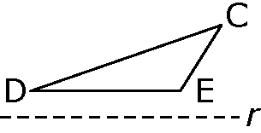
a) Use a Mira™ or mirror to reflect the image across
the line of reflection. Draw the reflected image.

b) Complete the statements to describe the reflected image for the diagram above.
The original image in the diagram has the point ____ as the highest point.
The new image shows the point ____ as the lowest point.
The new image has been reflected ____________________ (horizontally/vertically) in the line of reflection.
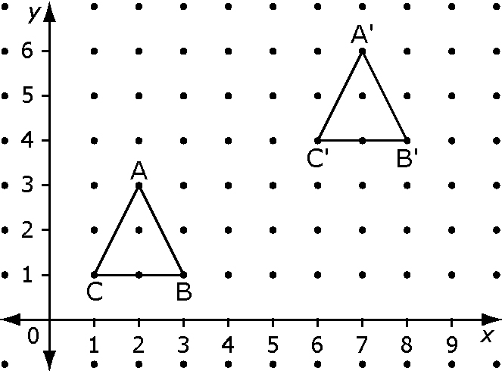
4. Examine the diagram to the right.

a) Figure ABC has been translated to create figure A'B'C'. Complete the following to determine a rule that could be used for translating ABC to A'B'C'.
To get point A to point A', move it ____ spaces right and ____ spaces up.
To get point B to point B', move it ____ spaces right and ____ spaces up.
To get point C to point C', move it ____ spaces right and ____ spaces up.

What is the rule for moving ABC to A'B'C'?
b) What is one other possible rule? Hint: Think about starting the move in another direction.
c) The original figure ABC is in quadrant I and the translated image A'B'C' is also in quadrant I. Suppose you want to move ABC to quadrant III. You could move point A from (2, 3) to A' at (–2, –3). Describe the move in words. Write a rule for moving the entire shape into quadrant III.

