Section 1.1 Extra Practice
For each of the following shapes,
a) determine the number of lines of symmetry
b) if possible, draw the lines of symmetry

Shape | a) Number of Lines | b) Draw Lines
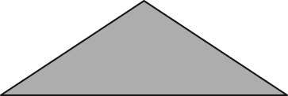
1.

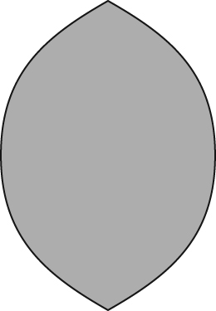
2.

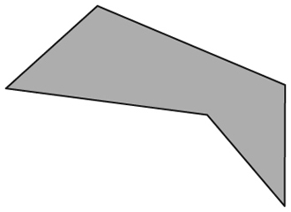
3.

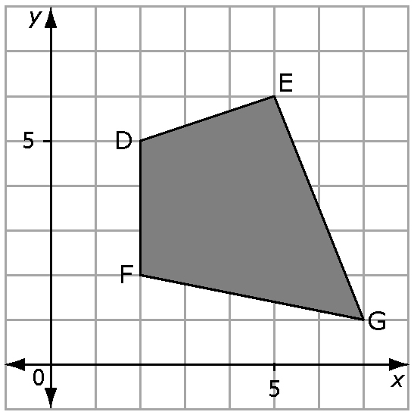
4. a) Redraw the figure DEFG using the x and y
coordinates in the diagram.
b) Draw the reflection image if the y-axis is the line
of reflection. Label the figure D'E'F'G'.
c) Draw the reflection image the of the figure DEFG if
the x-axis is the line of reflection. Label the figure
D"E"F"G".
d) Translate the figure DEFG 8 units to the left, and 7
units down. Label the translated image D"'E"'F"'G"'.

Is the figure D"'E"'F"'G"' a reflection of the figure D"E"F"G" with the y-axis as the line of reflection? Explain your reasoning.
_______________________________________________________________
_______________________________________________________________

