Section 1.1 Math Link
This worksheet will help you with the Math Link on page 15.

You are a designer for a company. You have been asked to create a design that has at least two lines of symmetry: horizontal, vertical, or diagonal.

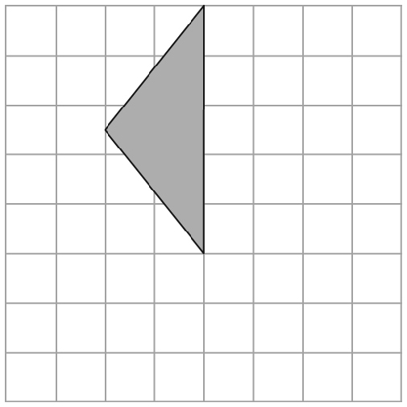
1. Use the diagram and follow these steps to create one
possible design.

a) Draw a line along a grid line that touches the figure.
This is the line of reflection.
b) Mark points on the vertices of the figure.
c) Count the distance of each point from the line of
reflection. Identify locations for points that are the
same distance on the other side of the line of reflection.
d) Connect the dots to make the shape.

2. Now, make your own design.
a) Fold a piece of grid paper in half vertically along one of the grid lines. Then, fold it horizontally along one of the grid lines.
b) Draw a line along each of the fold lines.
c) Draw one quarter of your design in one quadrant of the paper.
d) Mark points on your design.
e) Count the distance of each point from the vertical fold line. Identify locations for points that are the same distance on the other side of the vertical fold line.
f) Connect the dots to make half of your design.
g) Count the distance of each point in your new design from the horizontal fold line. Identify locations for points that are the same distance on the other side of the horizontal fold line.
h) Connect the dots to complete your design.

3. Another way to create a design is to use a Mira™.
a) Create your design on a piece of paper.
b) Choose and draw a vertical reflection line.
c) Place the Mira™ along this line to reflect your design.
d) Trace the image to make half of our design.
e) Choose and draw a horizontal reflection line.
f) Place the Mira™ along this line to reflect your new design.
g) Trace the image to complete your design.

