Section 1.2 Extra Practice
For #1 and 2, fill in the missing information.
a) What is the order of rotation?
b) What is the angle of rotation? Express in degrees and as a fraction of a turn.

 | a) Order | b) Angle
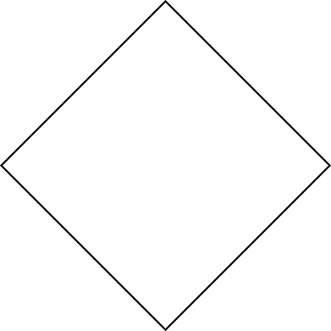
1.

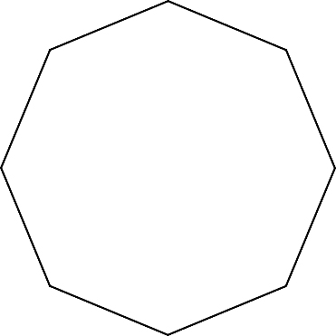
2.

For #3 and 4, fill in the missing information.
a) What is the number of lines of symmetry?
b) What is the order of symmetry?

 | a) Number | b) Order
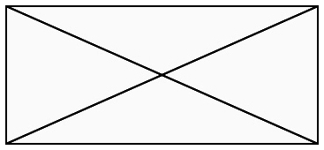
3.


4.

5. Draw the lines of symmetry and show the centre of rotation for the shapes in #3 and 4.

For #6 and 7, fill in the missing information.
a) What is the number of lines of symmetry?
b) What is the angle of rotation?

 | a) Number | b) Angle
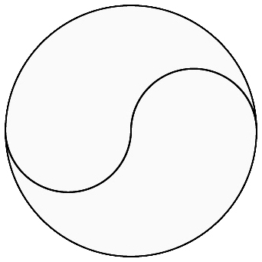
6.

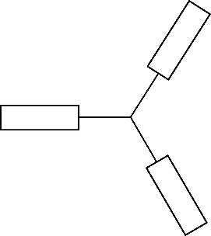
7.

8. The following capital letters are only half drawn. Complete the letters and draw the line(s) of reflection and/or the centre(s) of rotation of the completed letters.

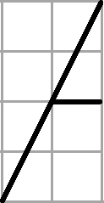
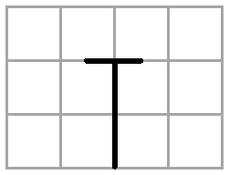
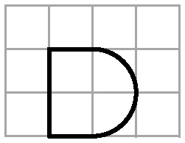
a) b) c)

d) Which letter can be completed using a reflection or a translation? Explain your answer.
___________________________________________________________________________
___________________________________________________________________________

