Section 1.2 Math Link
This worksheet will help you with the Math Link on page 25.

Your design company has asked you to create a design using rotational symmetry.
1. An example of a rotation is shown below.
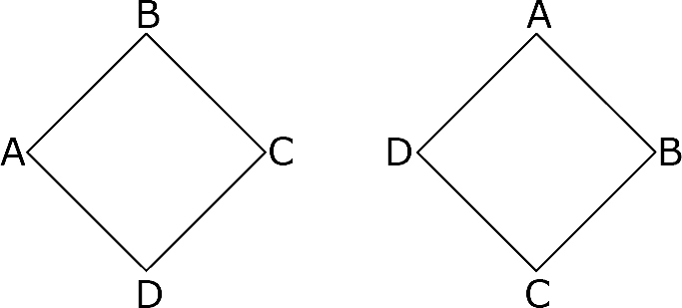

This design has been rotated ______° in a clockwise direction.

2. A design with rotational symmetry is shown below. Follow the steps to show how to create a design with rotational symmetry of 45°.
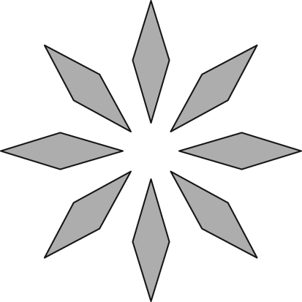

a) Use tracing paper to copy the diamond at the top and at the bottom of the design. Mark the centre.
b) Draw a line of symmetry through the two diamonds and the centre. This will be your design template.
c) Copy your first tracing on another piece of tracing paper. Set a protractor with the centre of your diagram and mark points at 45°, 90°, and 135°.
d) Set your design template behind the second piece of paper along the original line of reflection. Rotate it to the first point at 45°. Copy the design.
e) Rotate to 90° and copy the design.
f) Rotate to 135° and copy the design.
You should now have a design with rotational symmetry of 45°.

3. Use the steps above to create a design of your own. The design must have rotational symmetry.

