Section 1.3 Extra Practice
For #1 and 2, fill in the missing information.
a) Estimate the surface area.
b) Calculate the surface area. Show your work.
Each shape is constructed with centimetre cubes.

 | a) Estimate | b) Calculation
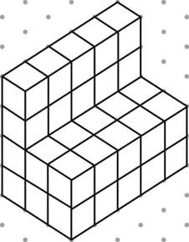
1.

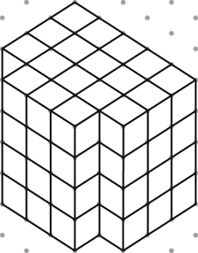
2.

3. The following objects have been drawn on isometric dot paper, where the distance between dots is 2 cm. Find the surface area of each object.
Object | Surface Area
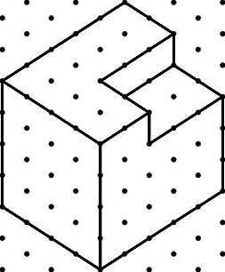
a)

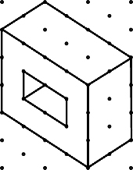
b)

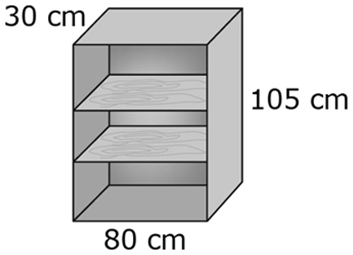
4. Jocelyn has built a set of shelves using unfinished wood.
The shelves are 2 cm thick. The back of the shelves is made
of thin plywood. She wants to apply a stain finish to the
entire surface.
What surface area does she need to stain? Group the surfaces so
that you can explain your work. Include a sentence answer.
______________________________________________________________
______________________________________________________________

