Chapter 1 Test
For #1 to 5, select the best answer.

1. Which figure has the largest number of lines of symmetry?
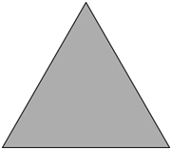
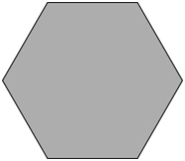
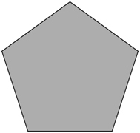
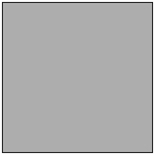
A B C D

2. Both line symmetry and rotation symmetry are shown in which figures?
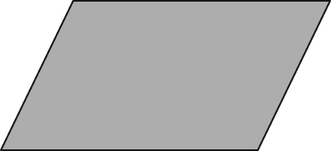
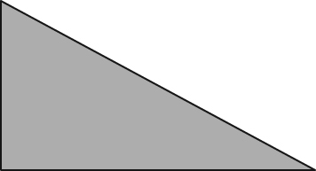
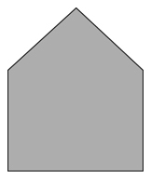
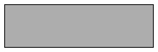
I II III IV

A I and III B II and III C I and IV D III and IV
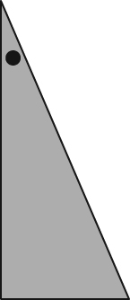
3. The figure to the right was rotated about a vertex.
Which image shows the resulting image?

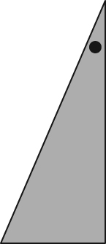
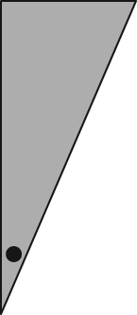
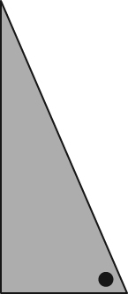
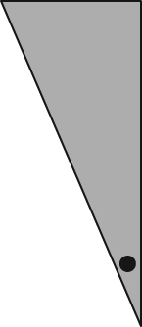
A B C D

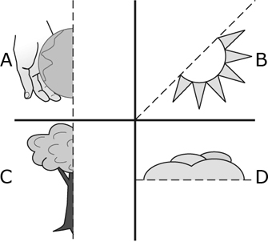
4. Imagine you complete each drawing using
the given line of symmetry. Which drawing has
rotation symmetry larger than two?

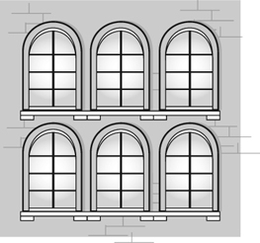
5. Which of the following statements is true when
describing the picture to the right?
A There is a horizontal line of symmetry.
B There is an oblique line of symmetry.
C The line of symmetry is vertical.
D A line of symmetry does not exist.

Complete the statements in #6 and 7.
6. The order of rotation of the snowflake shown in the diagram is .

7. If the diagram below is completed, the angle of rotation, rounded to the nearest tenth, is .
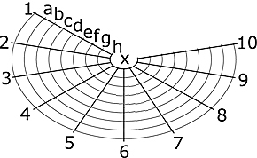
Short Answer
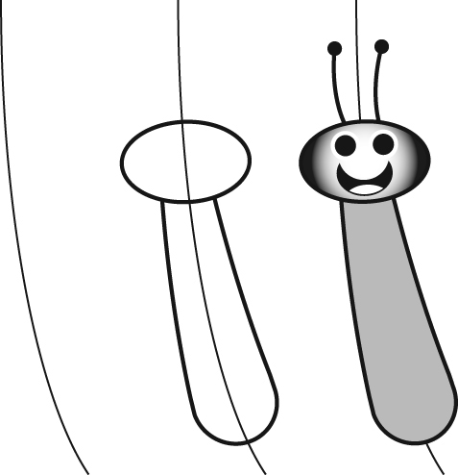
8. Omari told Erin that the cartoon figure he drew is symmetrical
with respect to a vertical line. Erin did not agree with Omari.
Do you agree with Omari or Erin? What argument could you
give to support your choice?
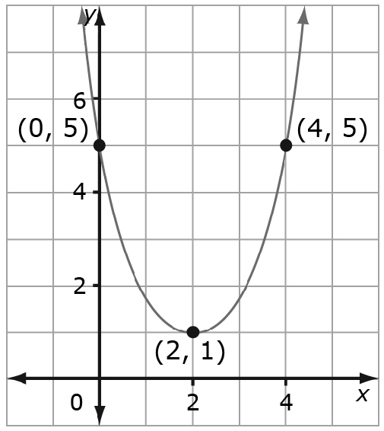
9. A graph is drawn on a coordinate grid.
a) Sketch the image of the graph after it is
translated 4 units to the left.
b) Label the coordinates of the translated
points.
c) Identify the type of symmetry that
results from the translation of the graph.

Extended Response
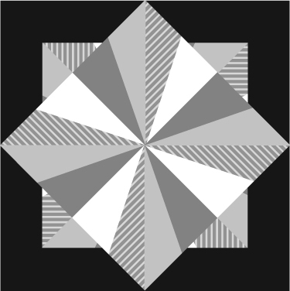
10. Colin was visiting the museum with his math class when he found
this piece of artwork.
a) Help Colin identify the lines of symmetry by drawing them in
and labelling the lines.
b) Colin recognized that the artwork displays rotation symmetry.
Identify the order and the angle of rotation.
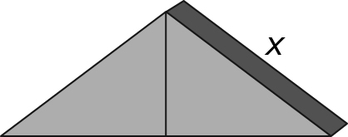
11. Two right triangular prisms are pushed together as shown.
The base of one triangle is 12 cm long and 2 cm deep. The height
of the triangle is 5 cm.
a) Determine the length of the missing side, x.
b) Determine the exposed surface area of the object.
c) What is the difference between the exposed surface area of the triangles when they are together and when they are separated?

