Chapter 1 BLM Answers

BLM 1–1 MathLinks 9 Scavenger Hunt
1. Chapter 4 Scale Factors and Similarity
2. Solving Linear Equations
3. page 410
4. Chapter Opener
5. a) The purpose is to make connections between the math and the real world or to what you already know.
b) The purpose is to make connections with math and personal experiences.
6. three
7. an activity called Explore the Language of Algebra
8. a) the beginning of the Link the Ideas section with an example showing how to represent inequalities
b) the key Ideas, which provide a summary of the main new concepts
9. a) Check Your Understanding
b) Communicate the Ideas, Practise, Apply,
and Extend
10. Problem Solving
11. a) Understand b) Plan c) Do It!
d) Look Back
12. a) Model It
b) Draw a Diagram
c) Make an Organized List or Table
d) Work Backward
e) Guess and Check
f) Look for a Pattern
g) Organize, Analyse, and Solve
h) Estimate and Check
i) Solve a Simpler Problem
j) Identify All Possibilities
k) Use a Variable
l) Solve an Equation
m) Make an Assumption
13. Foldable
14. Challenges
15. Reaction Time
16. Going Up?
17. a) Chapter 4 Review and Practice 4 Test
b) They help review the material in a chapter to prepare for a test.
18. a) Chapters 1-4 Review
b) at the end of Chapters 7 and 11
19. Glossary; page XXX
20. Index: It provides an alphabetical list of the book’s contents, with page references.

BLM 1–3 Chapter 1 Get Ready
1. a) Triangle ABC is translated 4 units up.
b) Rectangle EFGH is translated 4 units to the left and 5 units down.
2. a) P'(3, 3) b) The translation is 6 units to the right and 1 unit down.
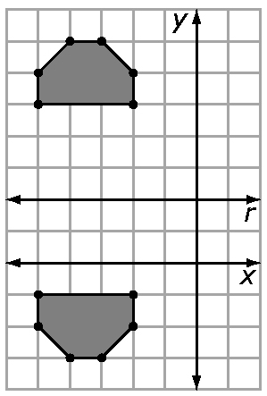
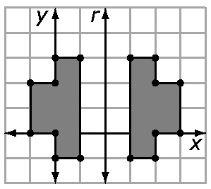
3. a) b)

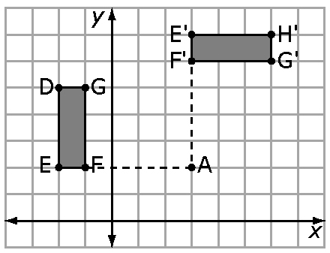
4. a)

b) D'(6, 7), E'(3, 7), F'(3, 6), G'(6, 6)
c) Example: A 90º clockwise rotation is the same as a 270º counter-clockwise rotation.
5. a) 286 cm² b) 108 m²
6. a) 5 b) 3
BLM 1–4 Chapter 1 Warm-Up
Section 1.1
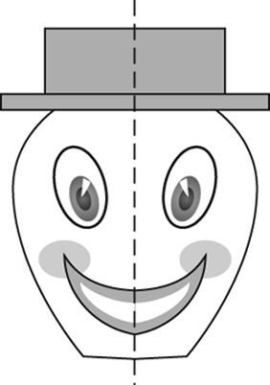
1.

2. Scalene triangle
3. A'(2, 4), C'(1, 0), E'(4, 1)
4. Isosceles
5. A, H, I, M, O, T, U, V, W, X, Y
6. A'(–2, 5) 7. B'(–3, –7)
8. C'(5, –9) 9. D'(6, –1)
10. The same answers
Section 1.2
1. H, I, O, X 2. Four
3. Example:
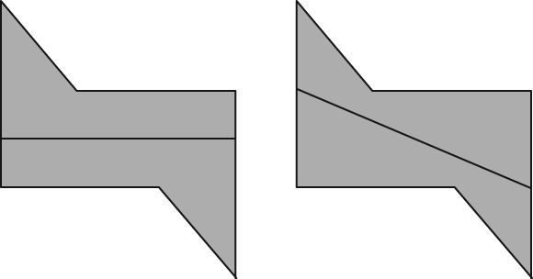
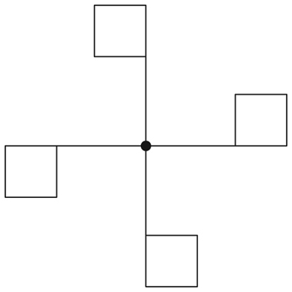
4.

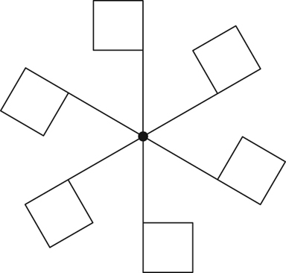
5.

6. 45º 7. 90º 8. 60º
9. One third 10. Three quarters

Section 1.3
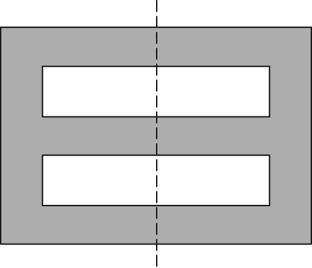
1.

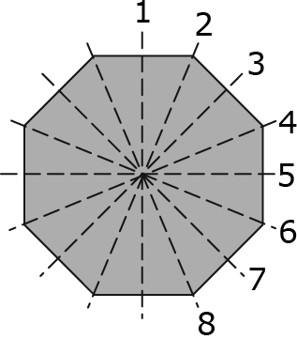
2. Eight;

3. Six 4. 72º, of a turn
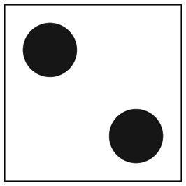
5. Example:

6. A = 37.5 cm² 7. A ≈ 48 cm²
8. 13 cm 9. 8 cm 10. 12 cm
BLM 1–5 Chapter 1 Problems of the Week
1. Square, hexagon, octagon. Any even-sided shape will appear to have not changed its orientation.
2. 24 cm
3. a) V = r³. If the water rises 100 mL,
V = 100 cm³ and therefore r = 2.88 cm. Since

S.A. = 4r², the surface area of the sphere is 104.2 cm².
b) V = area × depth, 104.2 × 0.1 cm = 10.4 cm³
BLM 1–6 Section 1.1 Extra Practice
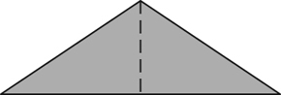
1. a) 1 b)

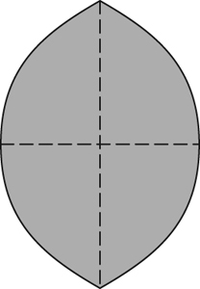
2. a) 2 b)

3. a) 0
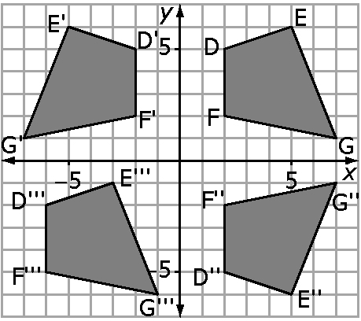
4. a) to d)

Example: No, because if it was a reflection, each of the reflected points would be the same distance from the y-axis as the original figure and they are not.
BLM 1–9 Section 1.2 Extra Practice
1. a) 4 b) 90°, turn
2. a) 8 b) 45°, turn
3. a) 2 b) 2 4. a) 5 b) 5

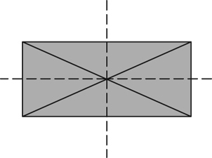
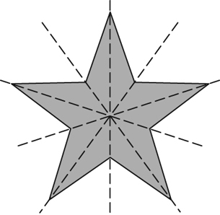
5.

,

6. a) 0 b) 180° 7. a) 3 b) 120°

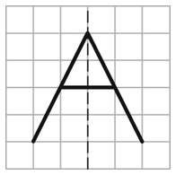
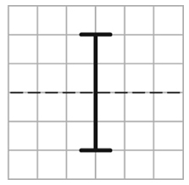
8. a) b)

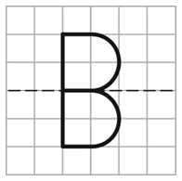
c)

d) B. The bottom half is a reflection of the top half. Also, the bottom half is a vertical downward translation image of the top half.

BLM 1–11 Section 1.3 Extra Practice
1. a) Example: sides = 24, top/bottom = 30, back/front = 40, total = 94 cm²
b) back = 20, 2 sides = 16, front = 30, bottom
= 15, top = 14, total = 95 cm²
2. a) Example: back/front = 40, sides = 32, top/bottom = 40, total = 112 cm²
b) back = 20, front = 28, top/bottom = 36, sides = 24, total = 108 cm²
3. a) front/back = 128, Sides = 160, top/bottom = 160, total = 448 cm²
b) sides = 48, top/bottom = 64, front/back
= 48 × 2 – 4 = 92, inside = 24, total = 228 cm²
4. Shelves: 7 × 76 × 30 = 15 960
Top and sides: (30 × 80) + 2(105 × 30)
= 2400 + 6300 = 8700
Back, inside surface: 76 × 103 = 7828
Outside surface: 80 × 105 = 8400
Front edges of top and sides: 2(2 × 103) + 2 × 80
= 412 + 160 = 572
Total: 15 960 + 8700 + 7828 + 8400 + 572
= 41 460
The surface area Jocelyn needs to stain is
41 460 cm².
BLM 1–14 Chapter 1 Test
1. B 2. C 3. D 4. B 5. C
6. 6 7. 25.7º
8. Erin. The cartoon is symmetrical to a curved line, not a straight line.
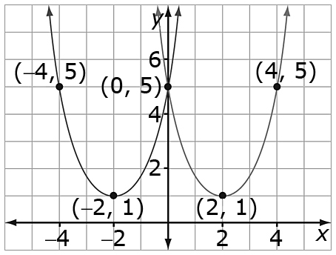
9. a)

b) (–2, 1), (–4, 5), and (0, 5)
c) Vertical line symmetry about the y-axis or the line x = 0.
10. a) one vertical, one horizontal, and two oblique lines of symmetry
b) order 4, angle 90º or turn
11. a) 13 cm b) 172 cm² c) 20 cm ²

