Chapter 2 Math Link Introduction
This worksheet will help you with the Math Link introduction on page 45.

1. a) A chessboard has a total of 64 light and dark squares. There are an equal number of light and dark squares. How many squares of each type are there? ____
b) A single square measures 3 cm by 3 cm as shown in the diagram. What is the area of this 3 cm-by-3 cm square? ____________________________
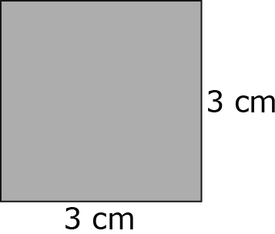
c) What is the total area of the dark squares? _______________________

2. a) A chessboard is square and has a total of 64 small squares. How many small squares make up one side of a chessboard? ____
b) The total area of a chessboard is 1024 cm². What is the side length of the board? _____________________________________________________
c) What is the side length of each small square? ______________________

3. a) Draw a square to represent the chessboard in #2. Draw a diagonal line from one corner to the other. The chessboard is divided into two
right-angle triangles. The diagonal is called the hypotenuse of the triangle.

b) Calculate the length of the diagonal of the chessboard. Use the Pythagorean relationship, a² + b² = c², where c is the hypotenuse, and a and b are the legs of the triangle. Express your answer to the nearest tenth of a centimetre.

4. Compare your solutions with your classmates’ solutions.

