Working With Decimal Numbers

Estimation can help you work with decimal numbers. For example, you can use estimation to place the decimal point in the correct position in the answer.
Place the decimal so that answer is close
to 100.
16.94 + 3.41 + 81.07 = 10 142
Estimate: 17 + 3 + 80 = 100
Calculation: 101.42

1. Without calculating the answer, place the decimal point in the correct position to make a true statement.
a) 149.8 ÷ 0.98 = 15285714
b) 2.7 × 100.9 = 272430
c) 40.6 × 9.61 = 39016600
d) 317 ÷ 99 = 32020202

2. Is 349 × 0.9 greater than, less than, or equal to 349? How do you know?
3. You know that 48 ÷ 16 = 3. Without finding the exact answer, tell whether the answer to 48 ÷ 15 is greater than, less than, or equal to 3. Explain how you know.

Understanding Fractions

A fraction can represent parts of a whole.
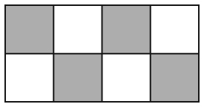
The shaded part of the diagram shows or or 0.5.
Compare and . Use denominators that are the same.
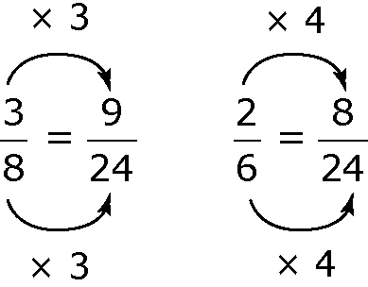
, therefore

4. Give the fraction and decimal value for the shaded part of each diagram.
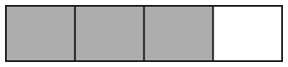
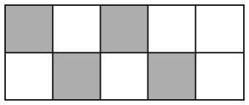
a) b)

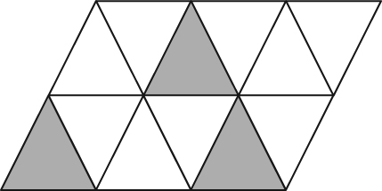
c)

5. Compare each set of fractions by arranging them from smallest to largest.
a) and b) , , and

Adding or Subtracting Fractions

When adding or subtracting fractions, work with parts of the whole that are of equal size. You can

• use diagrams
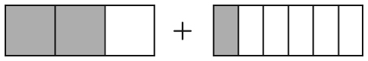
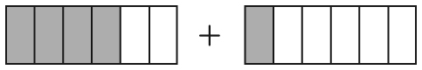
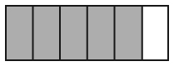
• use a common denominator

6. Write each statement shown by the fraction strips.
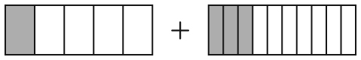
a)

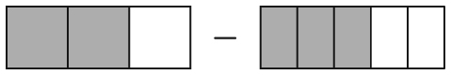
b)
7. Find the sum or difference. Give your answer in lowest terms.
a) + b) +
c) – d) –

Multiplying and Dividing Fractions

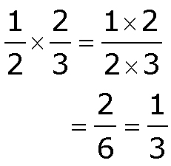
To multiply two proper fractions, you can multiply the numerators and multiply the denominators.

To divide two fractions, you can

• use a common denominator and divide the numerators
8. Multiply. Give your answer in lowest terms.
a) b) c)

• multiply by the reciprocal of the second fraction

9. Divide.
a) b) c)

C = × d
C ≈ 3 × 10
‪ C ≈ 30

