Section 2.1 Extra Practice
1. Identify the rational numbers.
a) 17 −3.606 –
b) –0.2 7.1234…
2. Write the opposite of each rational number.
a) 9 b) c) –17.6
d) e) 401 f) –7
3. Match each letter on the number line to one of the following rational numbers.
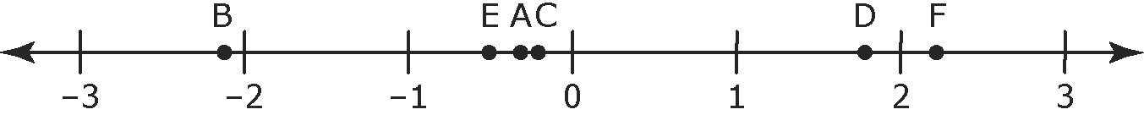
–0.3
–2.1 −
4. Compare , 1.7, –0.6, , and . Write the numbers in ascending order.
5. Compare –0.5, , , 1.9, and . Write the numbers in descending order.
6. Identify the equivalent fraction pairs.
a) , b) , c) ,
7. Identify the equivalent rational number pairs.
a) , b) , c) ,
8. Identify the smaller value in each pair.
a) , b) , c) ,
d) , e) , f) 0,
9. For each of the following pairs of rational numbers,
i) write the rational numbers in decimal form
ii) identify a decimal number between the pair of decimal numbers
a) , b) , c) ,
d) , e) , f) ,
10. For each of the following pairs of rational numbers,
i) write the rational numbers in fraction form
ii) identify a fraction between the pair of fractions
a) 0.8, 0.9 b) –0.65, –0.66 c) –0.9, –1
11. Express each rational number as a fraction or mixed number in lowest terms.
a) 7 ÷ (–14) b) –75 ÷ 100 c) –4.4
12. Which integers are between and ?

